**Sunday May 4, 2025**

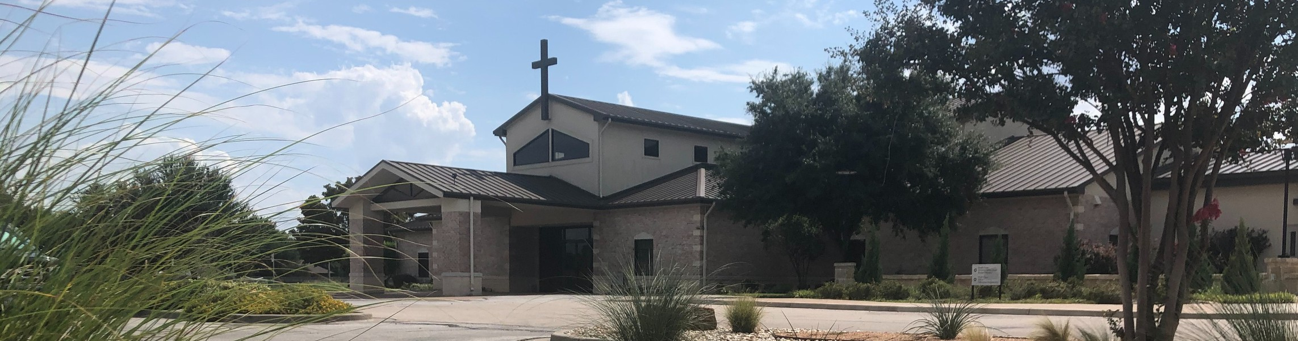

Welcome to Fellowship!

# Thank you for joining us for worship today! If you are a first-time visitor, please visit our Welcome Desk in the foyer or scan the QR code at right to complete a Guest Connect form.

U P C O M I N G E V E N T S



**Need Assistance?**

Visit the South Foyer Welcome Desk and our friendly Welcome Team will be glad to answer any questions or help you find the information you’re looking for!

**Need Coffee?**

Visit our Café in the North Foyer. Our Hospitality Team is ready to serve you!

**Need Prayer?**

If you would like someone to pray with you, our Prayer Team is available at the back of the Worship Center after each service.

Visit our website:

fellowshipwaco.org

Email us: [office@fellowshipwaco.org](mailto:office@fellowshipwaco.org)

Read and subscribe to our weekly newsletter: fellowshipwaco.org

Download our church app: fellowshipwaco.org/app

Telephone: 254.848.7200

|  |  |  |
| --- | --- | --- |
| Sun. | May 4 | ForeRunners Connection |
| Thur. | May 8 | ForeRunners Luncheon |
| Sun. | May 11 | Child Dedication Services |
| Sat. | May 17 | Men’s Breakfast |
| Sun. | May 18 | Discover LIFE Membership Class |
| Sun. | May 18 | Stephen Ministry Interest Meeting |
| Sun. | May 25 | Graduation Sunday for Seniors |

*For complete event details and registration, visit our website: fellowshipwaco.org/events*

*or scan the QR code at right.*

Follow Us On Social Media

*@fellowshipwaco*

Good Morning Fellowship!

How is your health? You may initially consider your level of physical well- being, but how is your soul? Today, we will learn how to live and lead with spiritual strength from 1 Timothy 4:6-8 so that it will be well with our soul.

Grant Kaul, Senior Pastor

**H o w t o L i v e a n d L e a d w i t h S p i r i t u a l S t r e n g t h**

**I n t e n t i o n a l C h u r c h :**

**T h e T r a i t s o f a C h u r c h i n L o v e w i t h C h r i s t**

**1 T i m o t h y 4 : 6 - 8**

**How do you live and lead with spiritual strength?**

**How to live and lead with spiritual strength:**

1. **Feed daily upon the word of God** **4:6**

4 Ways  to Give **In Service**

*Boxes in Worship Center*



**Online**

*fellowshipwaco.org/giving*



**App**

*fellowshipwaco.org/app*

**Mail**

*P.O. Box 21655*

*Waco, TX 76702*

1. **Forsake the fables of the world 4:7a**
2. **Foster spiritual practices into your life 4:7b-8**

**godliness:**

experiencing and expressing a love-based relationship with God and His word

***Our spiritual health is shaped by our habits.***

Take Next



Steps **Membership**

*fellowshipwaco.org/membership*



**Serve**

*fellowshipwaco.org/serve*



**Small Groups**

*fellowshipwaco.org/groups*

***My personal application of this passage:***



**Video from previous messages: youtube.com/fellowshipwaco Audio from previous messages: fellowshipwaco.org/podcasts Sermon notes online: fellowshipwaco.org/sermon-notes**

**Questions for individual study and LIFE Groups:**

* 1. Why do you think there are so many struggles and trials in life? Why must a Christian know how to live with spiritual strength?
  2. How does the phrase, “You are what you eat,” have meaning not just in our physical lives but also in our spiritual and emotional health?
  3. What are some of the “worldly fables” in our current culture that drive many people’s desires, attention, and actions? How does a spiritually healthy Christian interface with these secular ideals and philosophies?
  4. What are some benefits to “keeping in shape” physically? What are some parallels to your spiritual health?
  5. What are some central spiritual practices for living and leading with spiritual health? How have you been learning to develop these?