**Sunday June 15, 2025**

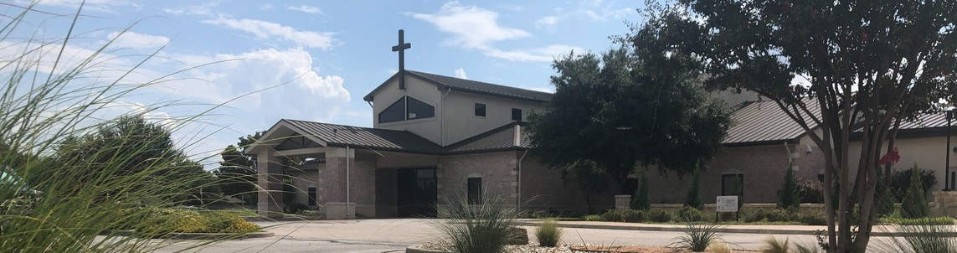

Welcome to Fellowship!

# Thank you for joining us for worship today! If you are a first-time visitor, please visit our Welcome Desk in the foyer or scan the QR code at right to complete a Guest Connect form.

U P C O M I N G E V E N T S

Follow Us On Social Media

*@fellowshipwaco*

Sun. Sun. Sun. Sun. Wed. Sat. Sun. Sun.

Fri. Sun.

June 15

June 15

June 15

June 15

June 18

June 21

June 29

June 29

July 4

July 6

Coffee & Connection Father’s Day

Child Dedication Family Sunday



**Need Assistance?**

Visit the South Foyer Welcome Desk and our friendly Welcome Team will be glad to answer any questions or help you find the information you’re looking for!

**Need Coffee?**

Visit our Café in the North Foyer. Our Hospitality Team is ready to serve you!

**Need Prayer?**

If you would like someone to pray with you, our Prayer Team is available at the back of the Worship Center after each service.

Visit our website:

fellowshipwaco.org

Email us: [office@fellowshipwaco.org](mailto:office@fellowshipwaco.org)

Read and subscribe to our weekly newsletter: fellowshipwaco.org

Download our church app: fellowshipwaco.org/app

Telephone: 254.848.7200

Summer Bible Studies begin Men’s Breakfast & Service Day PLACE Class begins Watermelon Sale for GBBMI

Church Office Closed E3 Event

*For complete event details and registration, visit our website: fellowshipwaco.org/events*

*or scan the QR code at right.*

Good Morning Fellowship!

On this Father’s Day, we will take a close look at the Father-heart of God for widows. In 1 Timothy 5:3-16, we will discover a call to honor the widows in our lives and the practical, life-giving ways they are to be cared for and esteemed.

Grant Kaul, Senior Pastor

**A C a l l t o H o n o r :**

**G u i d e l i n e s f o r t h e C a r e o f W i d o w s**

## I n t e n t i o n a l C h u r c h :

**T h e T r a i t s o f a C h u r c h i n L o v e w i t h C h r i s t**

**1 T i m o t h y 5 : 3 - 1 6**

**Why is it important for Christians to honor widows?**

**It reflects God’s heart**

**God commands it**

*Pure and undefiled religion in the sight of our God and Father is this: to visit orphans and widows in their distress, and to keep oneself*

*unstained by the world.*

James 1:27

**It models Christ-like compassion**

**It strengthens the family and the church family**

4 Ways

to Give **In Service**

*Boxes in Worship Center*

**Online**



*fellowshipwaco.org/giving*

**App**



*fellowshipwaco.org/app*

**Mail**

*P.O. Box 21655*

*Waco, TX 76702*

**Guidelines for a God-glorifying way to honor and care for widows: Widows with no living relatives 5:3, 5, 9-10, 16**

**Widows with living relatives** **5:4**

**Widows likely to remarry 5:11-15**

**How do Christians honor widows practically?**

 Show respect

 Value their presence and contributions

 Listen to their stories and learn from their wisdom  Help see that their needs are provided for

 Care for them emotionally and spiritually  Respect and receive their wisdom

How we go about our lives reveals what we believe about God.

***Let our love for God and His word guide how we care for the widows in our lives.***

Take Next



Steps **Membership**

*fellowshipwaco.org/membership*



**Serve**

*fellowshipwaco.org/serve*



**Small Groups**

*fellowshipwaco.org/groups*

***My personal application of this passage:***



**Video from previous messages: youtube.com/fellowshipwaco Audio from previous messages: fellowshipwaco.org/podcasts Sermon notes online: fellowshipwaco.org/sermon-notes**

## Questions for individual study and LIFE Groups:

1. Why is it important to honor widows?
2. How should Christians today think about caring for elderly parents or relatives in need?
3. What does verse 5 teach us about dependence on God in hard seasons of life?
4. Why is caring for family such a central Christian responsibility?
5. How does this passage challenge or encourage our church (or small group) to be more intentional in caring for those who are vulnerable or overlooked? What are some practical ways we can honor those who are widows?