**Sunday June 29, 2025**

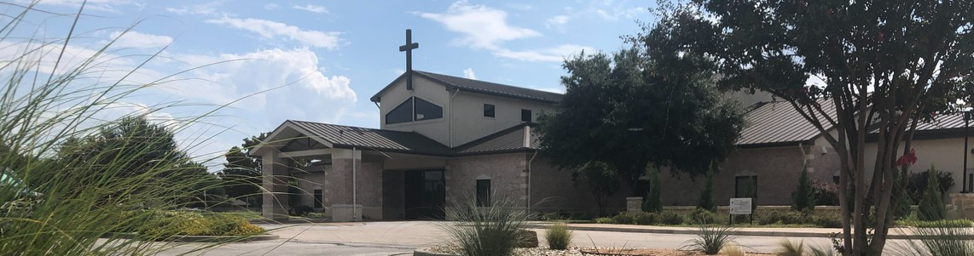

Welcome to Fellowship!

# Thank you for joining us for worship today! If you are a first-time visitor, please visit our Welcome Desk in the foyer or scan the QR code at right to complete a Guest Connect form.

Follow Us On Social Media

*@fellowshipwaco*

U P C O M I N G E V E N T S



**Need Assistance?**

Visit the South Foyer Welcome Desk and our friendly Welcome Team will be glad to answer any questions or help you find the information you’re looking for!

**Need Coffee?**

Visit our Café in the North Foyer. Our Hospitality Team is ready to serve you!

**Need Prayer?**

If you would like someone to pray with you, our Prayer Team is available at the back of the Worship Center after each service.

Visit our website:

fellowshipwaco.org

Email us: [office@fellowshipwaco.org](mailto:office@fellowshipwaco.org)

Read and subscribe to our weekly newsletter: fellowshipwaco.org

Download our church app: fellowshipwaco.org/app

Telephone: 254.848.7200

Sun. Sun. Sun. Sun.

Wed. Wed. Fri.

Sun. Sun. Sun. Sun. Sun. Sun. Wed. Thur.

June 29

June 29

June 29

June 29

July 2

July 2

July 4

July 6

July 6

July 6

July 6

July 6

July 6

July 9

July 10

PLACE Class begins Coffee & Connection Young Adult LIFE Group

Watermelon Sale for GBBMI

Summer Bible Studies Student Ministry Event Church Office Closed OCC Christmas in July ForeRunners Connection Coffee & Connection PLACE Class

Young Adult LIFE Group E3 Event - Fun

Summer Bible Studies ForeRunners Lunch

*For complete event details and registration, visit our website: fellowshipwaco.org/events*

*or scan the QR code at right.*

Good Morning Fellowship!

Did you know that our worship of God is to be revealed in the way we work? Many believers have not made this connection. As we discover in 1 Timothy 6:1-2, God puts His glory on display when we live out our faith at work.

Grant Kaul, Senior Pastor

**Work:**

**O u r F a i t h a t W o r k**

***I n t e n t i o n a l C h u r c h :***

***T h e T r a i t s o f a C h u r c h i n L o v e w i t h C h r i s t***

**1 T i m o t h y 6 : 1 - 2**

effort exerted in some purposeful activity. Work is a person’s

particular contribution to God’s good world and to the common good.

**How do believers in Christ manifest their relationship with Christ in the way they work?**

**How we manifest our relationship with Christ by the way we work:**

1. **Be respectful of those who have leadership responsibility 6:1a**

4 Ways

to Give **In Service**

*Boxes in Worship Center*

**Online**



*fellowshipwaco.org/giving*

**App**



*fellowshipwaco.org/app*

**Mail**

*P.O. Box 21655*

*Waco, TX 76702*

1. **Be purposeful to live out God’s truth for His glory 6:1b**
2. **Be faithful to serve to the fulness of our ability** **6:2**

***Our worship of God is to be revealed in the way that we work.***

Take Next



Steps **Membership**

*fellowshipwaco.org/membership*



**Serve**

*fellowshipwaco.org/serve*



**Small Groups**

*fellowshipwaco.org/groups*

***My personal application of this passage:***



**Video from previous messages: youtube.com/fellowshipwaco Audio from previous messages: fellowshipwaco.org/podcasts Sermon notes online: fellowshipwaco.org/sermon-notes**

**Questions for individual study and LIFE Groups:**

1. Why do you think many Christians struggle to see their daily work as an expression of worship? How might this mindset shift the way you approach your responsibilities?
2. What does it look like to show respect to those in authority, even when they are difficult or unjust?
3. How can our work either affirm or damage the credibility of the gospel in the eyes of others?
4. What motivates you to serve faithfully and diligently, especially in tasks that feel thankless or mundane?
5. Why is it essential that a church and its leaders understand and fulfill their roles?
6. What small step can you take this week to reflect Christ more clearly in your work?