**Sunday June 8, 2025**

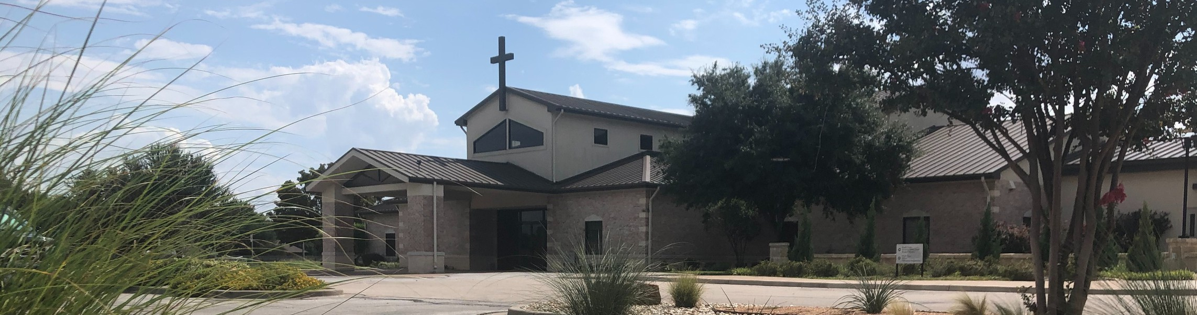

Welcome to Fellowship!

# Thank you for joining us for worship today! If you are a first-time visitor, please visit our Welcome Desk in the foyer or scan the QR code at right to complete a Guest Connect form.

U P C O M I N G E V E N T S

Follow Us On Social Media

*@fellowshipwaco*

Sun. Mon. Sat. Sun. Sun. Sun. Sun. Wed. Sat.

June 8

June 9

June 14

June 15

June 15

June 15

June 15

June 18

June 21

Coffee & Connection FX Camp begins MomLIFE Breakfast Coffee & Connection Father’s Day

Child Dedication Family Sunday



**Need Assistance?**

Visit the South Foyer Welcome Desk and our friendly Welcome Team will be glad to answer any questions or help you find the information you’re looking for!

**Need Coffee?**

Visit our Café in the North Foyer. Our Hospitality Team is ready to serve you!

**Need Prayer?**

If you would like someone to pray with you, our Prayer Team is available at the back of the Worship Center after each service.

Visit our website:

fellowshipwaco.org

Email us: [office@fellowshipwaco.org](mailto:office@fellowshipwaco.org)

Read and subscribe to our weekly newsletter: fellowshipwaco.org

Download our church app: fellowshipwaco.org/app

Telephone: 254.848.7200

Summer Bible Studies begin Men’s Breakfast

*For complete event details and registration, visit our website: fellowshipwaco.org/events*

*or scan the QR code at right.*

Good Morning Fellowship!

We are made for relationships, but how do we develop them in meaningful and God-honoring ways? This morning, we will explore the principles for healthy

and holy relationships as outlined in 1 Timothy 5:1-2.

Grant Kaul, Senior Pastor

**H o w t o H a v e H e a l t h y a n d H o l y R e l a t i o n s h i p s**

## I n t e n t i o n a l C h u r c h :

**T h e T r a i t s o f a C h u r c h i n L o v e w i t h C h r i s t**

**1 T i m o t h y 5 : 1 - 2**

**How do you have healthy and holy relationships?**

**The pattern for promoting healthy and holy relationships:**

**Start with our own heart (1 Tim. 4:10-16 review)**

**Grow in grace**

**Follow His word 1 Timothy 5:1-2**

4 Ways

to Give **In Service**

*Boxes in Worship Center*

**Online**



*fellowshipwaco.org/giving*

**App**



*fellowshipwaco.org/app*

**Mail**

*P.O. Box 21655*

*Waco, TX 76702*

**The God-honoring way to have healthy and holy relationships: Relating to older men as fathers 5:1a**

**Relating to younger men as brothers 5:1b**

**Relating to older women as mothers 5:2a**

**Relating to younger women as sisters 5:2b**

### The key to enjoying people is loving people.

*We love, because He first loved us.*

### 1 John 4:19

***How we see people shapes how we treat people.***

Take Next



Steps **Membership**

*fellowshipwaco.org/membership*



**Serve**

*fellowshipwaco.org/serve*



**Small Groups**

*fellowshipwaco.org/groups*

***My personal application of this passage:***



**Video from previous messages: youtube.com/fellowshipwaco Audio from previous messages: fellowshipwaco.org/podcasts Sermon notes online: fellowshipwaco.org/sermon-notes**

## Questions for individual study and LIFE Groups:

1. Why is it essential to start with our own heart when seeking healthy and holy relationships? How does personal spiritual growth affect the way we treat others?
2. What does it look like to “grow in grace” in our relationships, and why is grace necessary for honoring others?
3. How does God's word, especially 1 Timothy 5:1–2, guide us to relate differently to older men, younger men, older women, and younger women?
4. In practical terms, what does it mean to treat younger women “with all purity” as sisters? Why is this distinction important today?
5. How does knowing, experiencing, and expressing God’s love serve as the foundation for healthy and holy relationships?