**Sunday July 13, 2025**

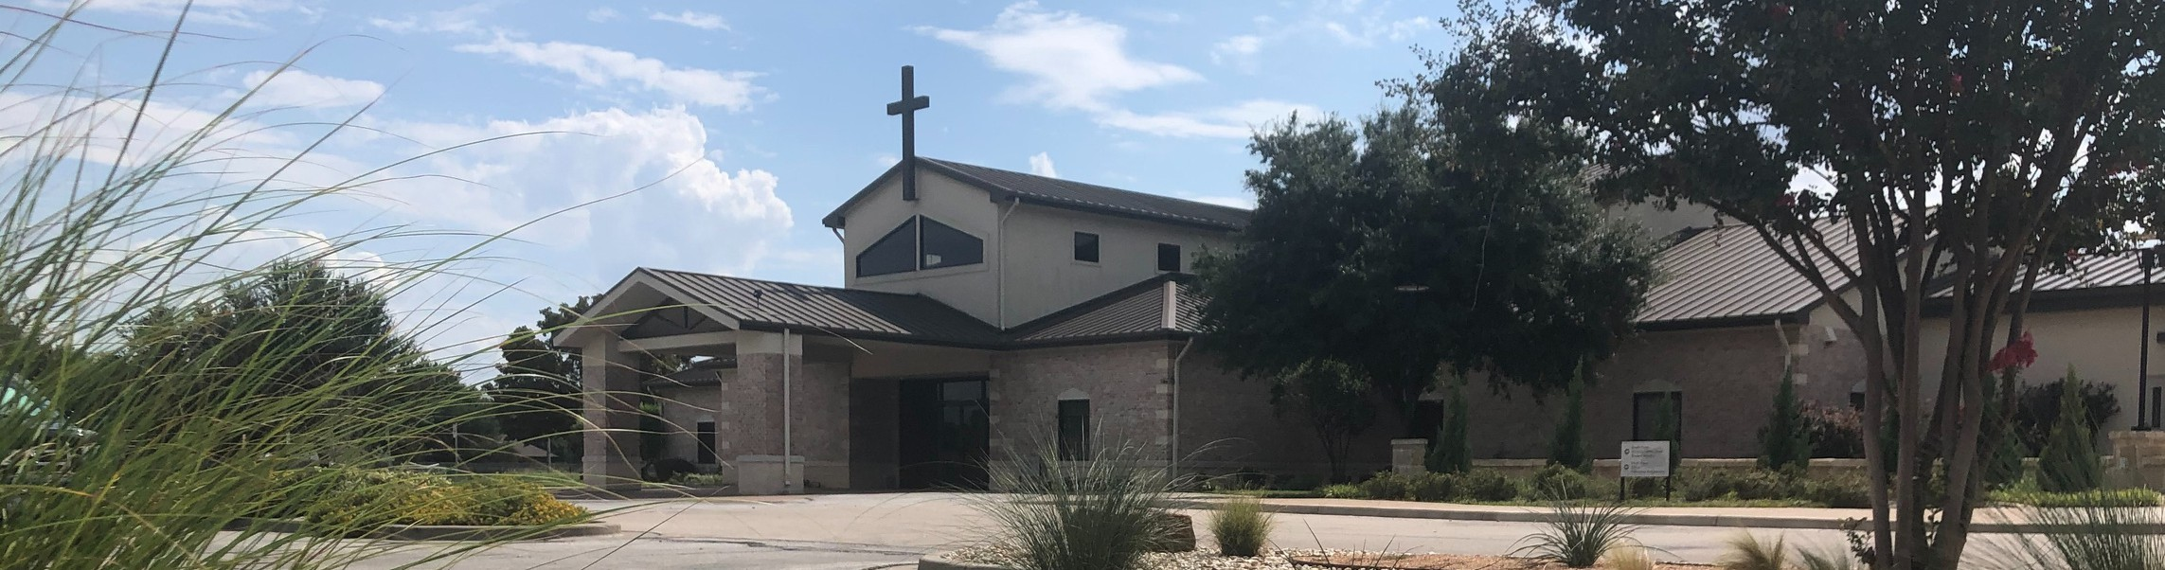

Welcome to Fellowship!

# Thank you for joining us for worship today! If you are a first-time visitor, please visit our Welcome Desk in the foyer or scan the QR code at right to complete a Guest Connect form.

U P C O M I N G E V E N T S

Follow Us On Social Media

*@fellowshipwaco*

Sun. Sun. Sun. Sun. Wed. Sat. Wed. Sat. Sun. Sun. Sun. Sun.

July 13

July 13

July 13

July 13

July 16

July 19

July 16

July 19

July 20

July 20

July 20

July 20

OCC Christmas in July Coffee & Connection Young Adult LIFE Group PLACE Class

Summer Bible Studies Men’s Breakfast Summer Bible Studies Men’s Breakfast



**Need Assistance?**

Visit the South Foyer Welcome Desk and our friendly Welcome Team will be glad to answer any questions or help you find the information you’re looking for!

**Need Coffee?**

Visit our Café in the North Foyer. Our Hospitality Team is ready to serve you!

**Need Prayer?**

If you would like someone to pray with you, our Prayer Team is available at the back of the Worship Center after each service.

Visit our website:

fellowshipwaco.org

Email us: [office@fellowshipwaco.org](mailto:office@fellowshipwaco.org)

Read and subscribe to our weekly newsletter: fellowshipwaco.org

Download our church app: fellowshipwaco.org/app

Telephone: 254.848.7200

OCC Christmas in July Coffee & Connection Young Adult LIFE Group PLACE Class

Lemonade Stand Supporting Isaiah 117 House: Fri. July 18, 10am-12pm - Ministry House

Sun. July 20, 10am-12:30pm - South Foyer

*For complete event details and registration, visit our website: fellowshipwaco.org/events*

*or scan the QR code at right.*

Good Morning Fellowship!

Do you know that we are engaged in a war being waged on multiple fronts? In 1 Timothy 6:11-12, we discover the two keys to fighting the good fight of faith.

Grant Kaul, Senior Pastor

**H o w t o F i g h t t h e G o o d F i g h t o f F a i t h**

***I n t e n t i o n a l C h u r c h :***

***T h e T r a i t s o f a C h u r c h i n L o v e w i t h C h r i s t***

**1 T i m o t h y 6 : 1 1 - 1 2**

**Do you know that you are in a war?**

**How do we fight the good fight of faith?**

**The two keys to fighting the good fight of faith:**

1. **Flee from sin 6:11a**

**The temptations we face:**

* + Desire of the flesh
  + Desire of the eyes
  + Pride of life

**How we overcome temptation:**

* + Calling it what it is
  + Calling out to God
  + Connecting with God’s people

4 Ways

to Give **In Service**

*Boxes in Worship Center*

**Online**



*fellowshipwaco.org/giving*

**App**



*fellowshipwaco.org/app*

**Mail**

*P.O. Box 21655*

*Waco, TX 76702*

1. **Pursue growing in the life we have in Christ 6:11b-12 6:11b**

**6:12**

**Pursue growing in the life we have in Christ in the following ways:**

* + **Proactively**
  + **Personally**
  + **Publicly**

*Now flee from youthful lusts and pursue righteousness, faith, love and peace, with those who call on the Lord from a pure heart.*

2 Timothy 2:22

**Two questions to ask:**

*Lord, what would maturity in Christ look like in this relationship/situation? Lord, would you give me the grace, desire, and strength to live this way?*

***Fight the good fight of faith by fleeing from sin and pursuing the life we have in Christ.***

Take Next



Steps **Membership**

*fellowshipwaco.org/membership*



**Serve**

*fellowshipwaco.org/serve*



**Small Groups**

*fellowshipwaco.org/groups*

***My personal application of this passage:***



**Video from previous messages: youtube.com/fellowshipwaco Audio from previous messages: fellowshipwaco.org/podcasts Sermon notes online: fellowshipwaco.org/sermon-notes**

**Questions for individual study and LIFE Groups:**

1. What does it look like to be aware that we are in a spiritual war, and how does that awareness shape your daily decisions?
2. What are common ways you see these three areas of temptation (desire of the flesh, eyes, or pride of life) manifested, and how can you practically “flee” from it?
3. How has the approach of calling temptation what it is, calling out to God, and connecting with God's people helped you in overcoming temptation, and why?
4. How would you describe your current spiritual pursuits? In what ways can you more proactively, personally, and publicly pursue life in Christ this week?
5. What would maturity in Christ look like in a current challenge or relationship you’re facing, and have you asked God for the grace and strength to live that way?