**Sunday July 20, 2025**

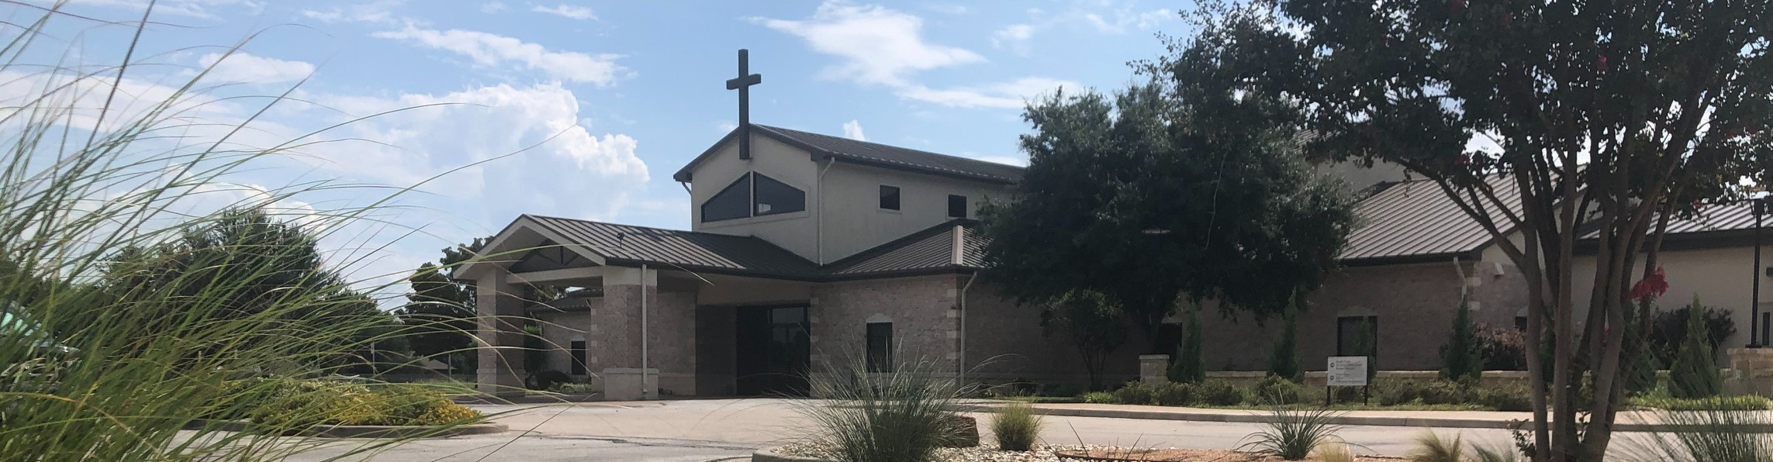

Welcome to Fellowship!

# Thank you for joining us for worship today! If you are a first-time visitor, please visit our Welcome Desk in the foyer or scan the QR code at right to complete a Guest Connect form.

U P C O M I N G E V E N T S

Follow Us On Social Media

*@fellowshipwaco*

Sun. Sun. Sun. Sun. Sun. Sun. Wed. Sun. Sun. Sun. Sun. Sun.

July 20

July 20

July 20

July 20

July 20

July 20

July 23

July 27

July 27

July 27

July 27

July 27

OCC Christmas in July Coffee & Connection Young Adults LIFE Group PLACE Class

LIFE Group Ldrs. Meeting It’s Good to be a LiveWire Summer Bible Studies OCC Christmas in July Coffee & Connection Young Adults LIFE Group PLACE Class



**Need Assistance?**

Visit the South Foyer Welcome Desk and our friendly Welcome Team will be glad to answer any questions or help you find the information you’re looking for!

**Need Coffee?**

Visit our Café in the North Foyer. Our Hospitality Team is ready to serve you!

**Need Prayer?**

If you would like someone to pray with you, our Prayer Team is available at the back of the Worship Center after each service.

Visit our website:

fellowshipwaco.org

Email us: [office@fellowshipwaco.org](mailto:office@fellowshipwaco.org)

Read and subscribe to our weekly newsletter: fellowshipwaco.org

Download our church app: fellowshipwaco.org/app

Telephone: 254.848.7200

LIFE Group Ldrs. Meeting

TODAY

Lemonade Stand Supporting Isaiah 117 House

*For complete event details and registration, visit our website: fellowshipwaco.org/events*

*or scan the QR code at right.*

Good Morning Fellowship!

Last week we learned how to fight the good fight of faith, but this morning we’re diving into why we fight—unpacking the powerful motivations in 1

Timothy 6:13-16 that fuel our passion to stand firm for Christ. From the Giver of Life to the Sovereign King, discover what drives us to live boldly and

faithfully until He returns!

George Ohmstede, Associate Pastor

**M o t i v a t e d b y M a j e s t y :**

***S t a n d i n g F i r m i n t h e G o o d F i g h t o f F a i t h***

***I n t e n t i o n a l C h u r c h :***

***T h e T r a i t s o f a C h u r c h i n L o v e w i t h C h r i s t***

**1 T i m o t h y 6 : 1 3 - 1 6**

## The 13

* We are motivated by the of
* We are motivated by the of

The of the good - Jesus

## The 14

* We are motivated by the of to

holiness and righteousness

* We are motivated by the of until the return of Christ

4 Ways

to Give **In Service**

*Boxes in Worship Center*

**Online**



*fellowshipwaco.org/giving*

**App**



*fellowshipwaco.org/app*

**Mail**

*P.O. Box 21655*

*Waco, TX 76702*

## The 15

* We are motivated by the of the and

## The 16

* We are motivated by the of the King

and Lord

**The**  **and** **16**

* We are motivated by the and through the of

who our God is

* The One to be
* And the One who will have for eternity!

Take Next



Steps **Membership**

*fellowshipwaco.org/membership*



**Serve**

*fellowshipwaco.org/serve*



**Small Groups**

*fellowshipwaco.org/groups*

***My personal application of this passage:***



**Video from previous messages: youtube.com/fellowshipwaco Audio from previous messages: fellowshipwaco.org/podcasts Sermon notes online: fellowshipwaco.org/sermon-notes**

**Questions for individual study and LIFE Groups:**

1. How does recognizing God as the Giver of Life inspire us to fight the good fight of faith? In what ways does Jesus’ good confession, as the Giver of Truth, motivate us to stand firm in our faith?
2. How does the command to remain committed until Christ’s return shape our daily spiritual battles?
3. What does the certainty of Jesus as our King and Lord provide us in the face of life’s challenges?
4. How do the characteristics of God’s sovereignty, as described in verse 16, strengthen our resolve to persevere?
5. How can we cultivate a deeper confidence in God’s eternal dominion to fuel our faith?
6. How does the conviction of God’s majesty influence our motivation to live out our faith boldly?