**July 27, 2025**

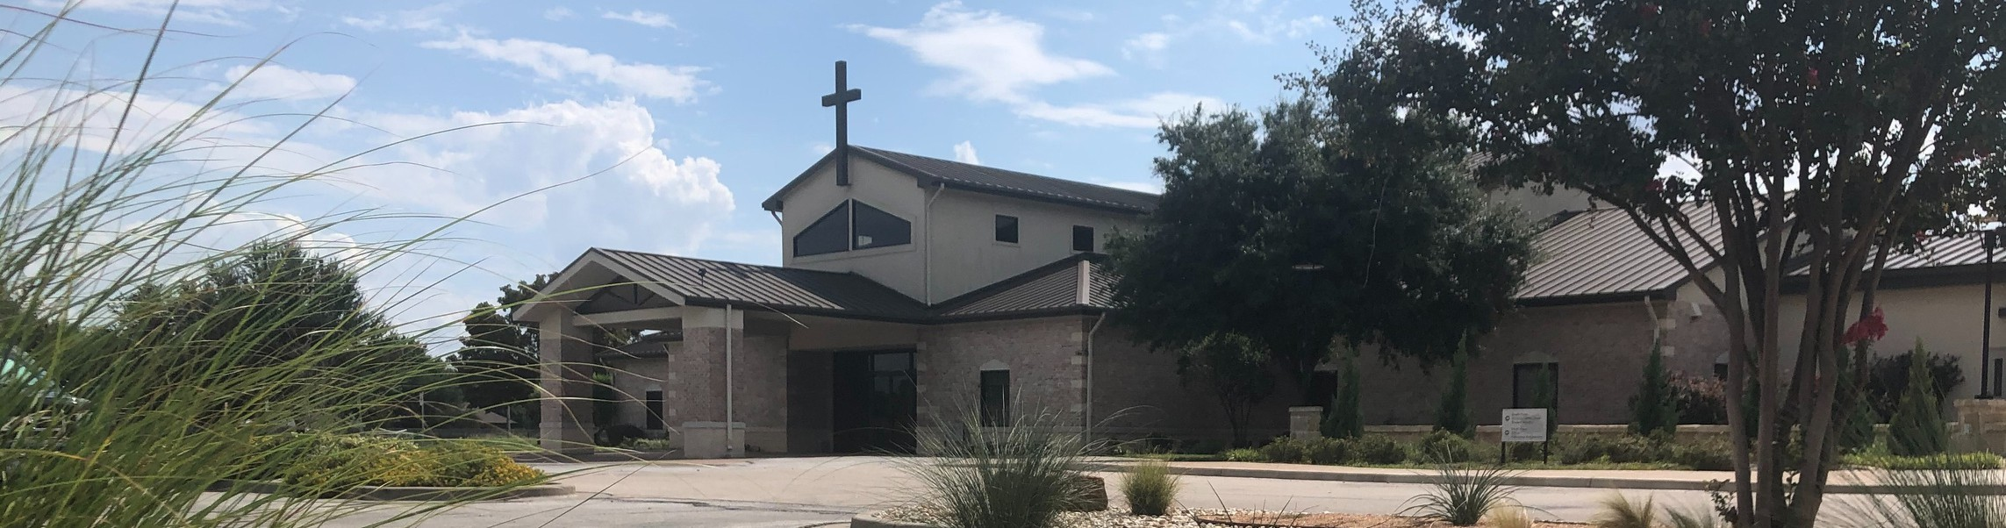

Welcome to Fellowship!

# Thank you for joining us for worship today! If you are a first-time visitor, please visit our Welcome Desk in the foyer or scan the QR code at right to complete a Guest Connect form.

Follow Us On Social Media

*@fellowshipwaco*

U P C O M I N G E V E N T S

Sun. Sun. Sun. Sun. Sun. Mon. Wed.

Fri. Sun. Sun. Sun. Sun. Sun.

July 27

July 27

July 27

July 27

July 27

July 28

July 30

Aug. 1

Aug. 3

Aug. 3

Aug. 3

Aug. 3

Aug. 3

OCC Christmas in July Coffee & Connection Young Adults LIFE Group PLACE Class

LIFE Group Ldrs. Meeting Students depart for Mission Camp Wednesday night Bible Studies



**Need Assistance?**

Visit the South Foyer Welcome Desk and our friendly Welcome Team will be glad to answer any questions or help you find the information you’re looking for!

**Need Coffee?**

Visit our Café in the North Foyer. Our Hospitality Team is ready to serve you!

**Need Prayer?**

If you would like someone to pray with you, our Prayer Team is available at the back of the Worship Center after each service.

Visit our website:

fellowshipwaco.org

Email us: [office@fellowshipwaco.org](mailto:office@fellowshipwaco.org)

Read and subscribe to our weekly newsletter: fellowshipwaco.org

Download our church app: fellowshipwaco.org/app

Telephone: 254.848.7200

Students return from Mission Camp Coffee & Connection

Young Adults LIFE Group PLACE Class ForeRunners Connection E3 Event with Baptisms

**Discover LIFE Membership Class Sunday Aug. 17 9am-12pm Register at fellowshipwaco.org**

*For complete event details and registration, visit our website: fellowshipwaco.org/events*

*or scan the QR code at right.*

Good Morning Fellowship!

Author and cleric Jonathan Swift once said, “May you live all the days of your life”. At first that struck me as funny. Then witty.Then profound. How do we do that, in a godly way, as opposed to the prideful, self-centered, materialistic

way that our culture encourages? The answer found in 1 Timothy 6:17-21 will reverberate for eternity.

Brian Davis, Elder

**T h e L i f e t h a t i s T r u l y L i f e**

***I n t e n t i o n a l C h u r c h :***

***T h e T r a i t s o f a C h u r c h i n L o v e w i t h C h r i s t***

**1 T i m o t h y 6 : 1 7 - 2 1**

## Long for God v. 17

**Lead a generous life v. 18**

4 Ways

to Give **In Service**

*Boxes in Worship Center*

**Online**



*fellowshipwaco.org/giving*

**App**



*fellowshipwaco.org/app*

**Mail**

*P.O. Box 21655*

*Waco, TX 76702*

## Lay up treasure in heaven v. 19

 2 Corinthians 8:3-4 tells us giving is to be proportionate, sacrificial, voluntary, and joyful

*For I testify that they gave as much as they were able, and even beyond their ability. Entirely on their own, they urgently pleaded with us for the privilege of sharing in this service to the saints.*

## Guard the truth v. 20

**Grace be with you v. 21**

***The true life longs for God, leads with generosity,***

***and lays up treasure in heaven, as we live out God’s word.***

Take Next



Steps **Membership**

*fellowshipwaco.org/membership*



**Serve**

*fellowshipwaco.org/serve*



**Small Groups**

*fellowshipwaco.org/groups*

***My personal application of this passage:***



**Video from previous messages: youtube.com/fellowshipwaco Audio from previous messages: fellowshipwaco.org/podcasts Sermon notes online: fellowshipwaco.org/sermon-notes**

**Questions for individual study and LIFE Groups:**

1. Think about the command to the “rich” that Paul describes to Timothy. The sermon made the point that this applies to virtually everyone who hears this message. Do you agree or disagree with that statement? Why?
2. In what ways is wealth uncertain?
3. Do you know that God wants you to enjoy the material blessings He provides in this life? (Eccl. 5:18-19)
4. What does it look like to lead a generous life in all aspects – your time, talent, treasure, and tribe?
5. How do you stay focused on the eternal rewards that await a generous life rather than getting caught up in the here-and-now?
6. What are next steps you can take to guard God’s word and pursue a holy life that is pleasing to God?
7. Who in your life and sphere of influence can be your “O Timothy” relationship? How can you foster that relationship?