**Sunday July 6, 2025**

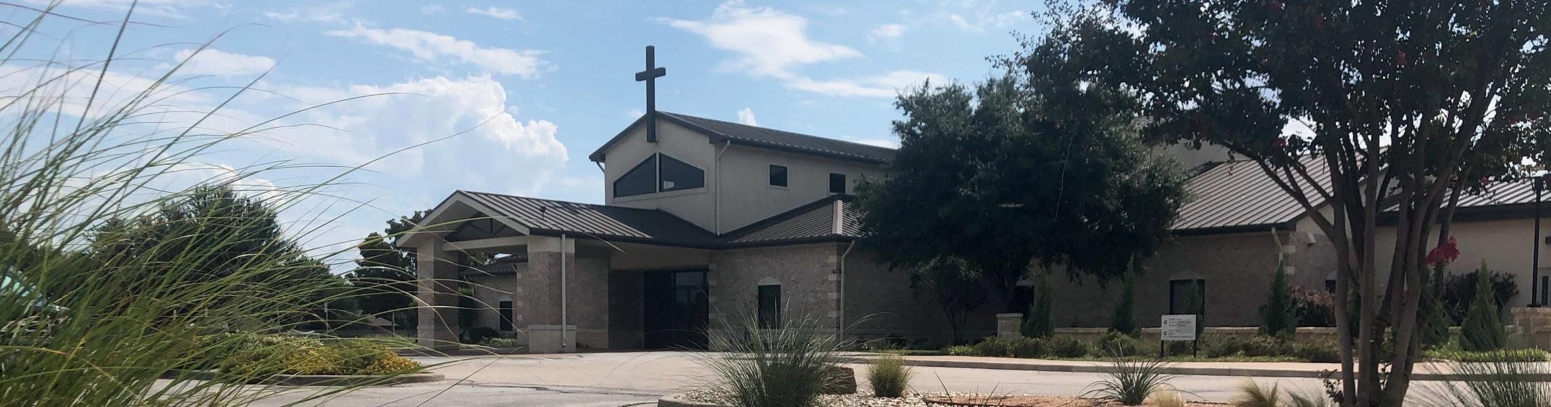

Welcome to Fellowship!

# Thank you for joining us for worship today! If you are a first-time visitor, please visit our Welcome Desk in the foyer or scan the QR code at right to complete a Guest Connect form.

U P C O M I N G E V E N T S

Follow Us On Social Media

*@fellowshipwaco*

Sun. Sun. Sun. Sun. Sun. Sun. Tues. Wed. Wed. Thur. Sun. Sun. Sun. Sun. Wed. Sat.

July 6

July 6

July 6

July 6

July 6

July 6

July 8

July 9

July 9

July 10

July 13

July 13

July 13

July 13

July 16

July 19

OCC Christmas in July ForeRunners Connection Coffee & Connection Young Adult LIFE Group PLACE Class

E3 Event - Fun LiveWires Pool Party Summer Bible Studies



**Need Assistance?**

Visit the South Foyer Welcome Desk and our friendly Welcome Team will be glad to answer any questions or help you find the information you’re looking for!

**Need Coffee?**

Visit our Café in the North Foyer. Our Hospitality Team is ready to serve you!

**Need Prayer?**

If you would like someone to pray with you, our Prayer Team is available at the back of the Worship Center after each service.

Visit our website:

fellowshipwaco.org

Email us: [office@fellowshipwaco.org](mailto:office@fellowshipwaco.org)

Read and subscribe to our weekly newsletter: fellowshipwaco.org

Download our church app: fellowshipwaco.org/app

Telephone: 254.848.7200

Student Mission Camp Parent Mtg ForeRunners Luncheon

OCC Christmas in July Coffee & Connection Young Adult LIFE Group PLACE Class

Summer Bible Studies Men’s Breakfast

*For complete event details and registration, visit our website: fellowshipwaco.org/events*

*or scan the QR code at right.*

Good Morning Fellowship!

As believers, how do we discern truth from error and find true contentment while living in a world obsessed with wealth, status, and self-promotion? This morning, we look to 1 Timothy 6:3-10 to answer this question, as Paul reminds us that godliness is great gain!

George Ohmstede, Associate Pastor

**T r u e C o n t e n t m e n t : G u a r d i n g t h e G o s p e l , G r e a t G a i n , a n d G o d l i n e s s o v e r G r e e d !**

***I n t e n t i o n a l C h u r c h :***

***T h e T r a i t s o f a C h u r c h i n L o v e w i t h C h r i s t***

**1 T i m o t h y 6 : 3 - 1 0**

1. **Guard the gospel through sound doctrine *vv. 3-5***

4 Ways

to Give **In Service**

*Boxes in Worship Center*

**Online**



*fellowshipwaco.org/giving*

**App**



*fellowshipwaco.org/app*

**Mail**

*P.O. Box 21655*

*Waco, TX 76702*

1. **Great gain comes through godliness**

**accompanied with contentment *vv. 6-8***

1. **Godliness will protect the heart from the temptation and grief of greed**
2. ***9-10***

Take Next



Steps **Membership**

*fellowshipwaco.org/membership*



**Serve**

*fellowshipwaco.org/serve*



**Small Groups**

*fellowshipwaco.org/groups*

***My personal application of this passage:***



**Video from previous messages: youtube.com/fellowshipwaco Audio from previous messages: fellowshipwaco.org/podcasts Sermon notes online: fellowshipwaco.org/sermon-notes**

**Questions for individual study and LIFE Groups:**

* 1. What doctrine and sound words is Paul referring to in verse 3?
  2. According to verse 4, what are the consequences for the false teacher and what is he trying to gain by manipulating the scriptures?
  3. Do a quick word study of the word godliness, then provide your own definition according to scripture.
  4. Why does Paul use food and covering as the basic guidelines to contentment?
  5. According to verse 10, why does the love of money cause people to walk away from the faith as well as cause great grief?