**August 10, 2025**

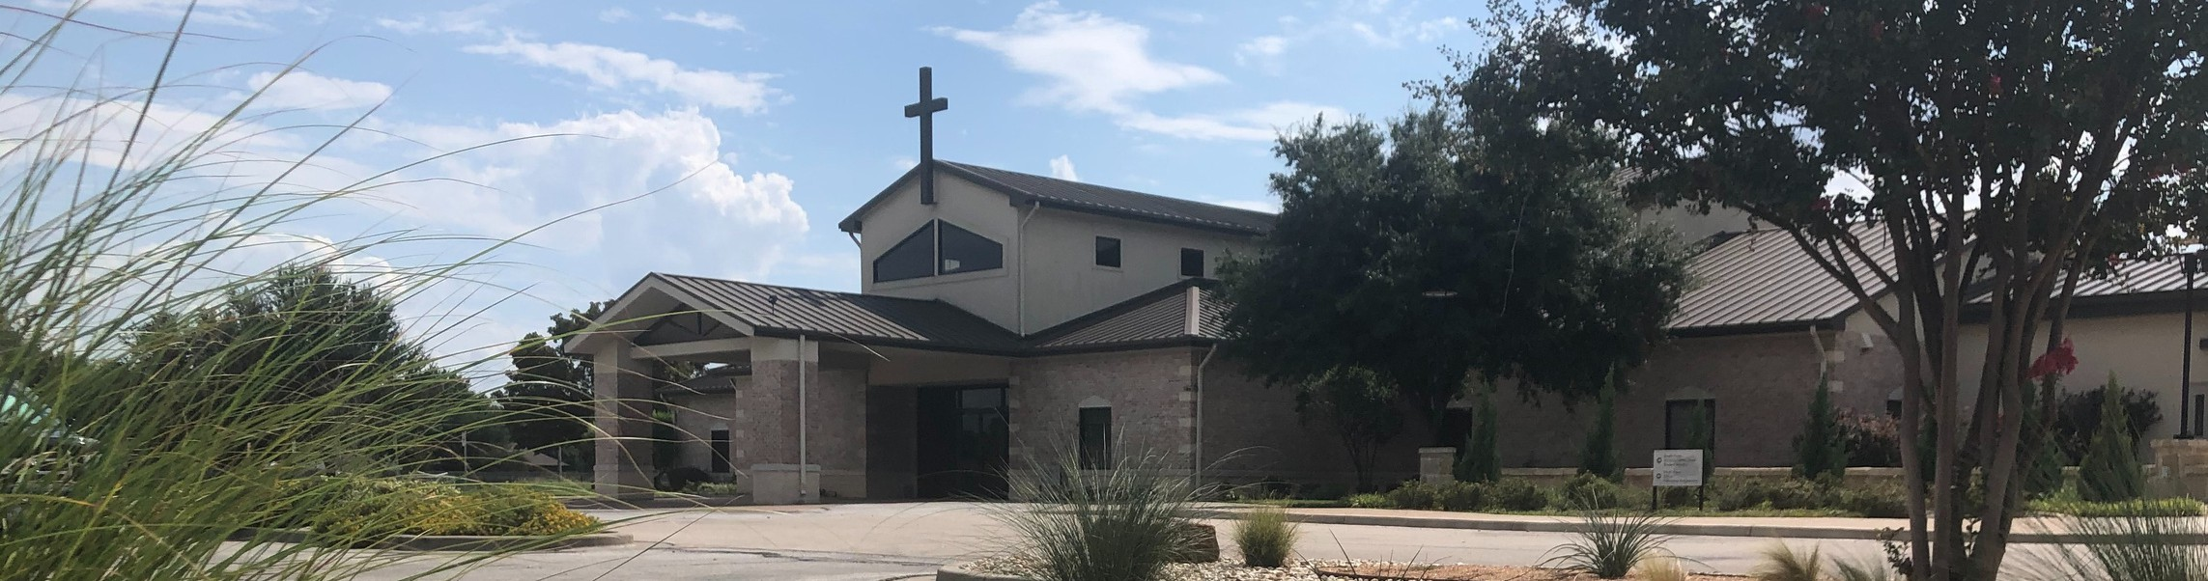

Welcome to Fellowship!

# Thank you for joining us for worship today! If you are a first-time visitor, please visit our Welcome Desk in the foyer or scan the QR code at right to complete a Guest Connect form.

Follow Us On Social Media

*@fellowshipwaco*

U P C O M I N G E V E N T S

Sun. Sun. Thur. Thur. Sat. Sun. Wed. Sun. Sun. Sun.

Aug. 10

Aug. 10

Aug. 14

Aug. 14

Aug. 16

Aug. 17

Aug. 20

Aug. 24

Aug. 24

Aug. 31

Promotion Sunday!

New Sermon Series - Ezra ForeRunners Ice Cream Social Church Office Closed



**Need Assistance?**

Visit the South Foyer Welcome Desk and our friendly Welcome Team will be glad to answer any questions or help you find the information you’re looking for!

**Need Coffee?**

Visit our Café in the North Foyer. Our Hospitality Team is ready to serve you!

**Need Prayer?**

If you would like someone to pray with you, our Prayer Team is available at the back of the Worship Center after each service.

Visit our website:

fellowshipwaco.org

Email us: [office@fellowshipwaco.org](mailto:office@fellowshipwaco.org)

Read and subscribe to our weekly newsletter: fellowshipwaco.org

Download our church app: fellowshipwaco.org/app

Telephone: 254.848.7200

Men’s Breakfast

Discover LIFE Membership Class Student Ministry Fall Kickoff School Outreach Interest Meeting Kids Ministry Volunteer Training Family Worship Sunday

**Fall Kickoff 2025 Bible Studies, Kids Ministry,**

**MomLIFE and more begin the week of Sept. 8!**

*For complete event details and registration, visit our website: fellowshipwaco.org/events*

*or scan the QR code at right.*

Good Morning Fellowship!

What do your daily patterns reveal about your heart? In every area of life, our habits reveal what we truly value, and nowhere is that more important than in our walk with God. Starting this morning, we will explore the life of Ezra and uncover how his intentional practices transformed his life and reshaped the

spiritual direction of an entire nation, and how they can do the same for us.

Grant Kaul, Senior Pastor

**T h e E z r a E x p e r i e n c e P a r t 1 :**

**S e t Y o u r H e a r t t o K n o w G o d a n d H i s W o r d**

**E z r a 7 : 1 - 1 0**

**What are the patterns of your life? Introduction to Ezra’s Ministry**

**The Ezra Experience - The lifelong practice of life-giving believers is to intentionally pursue three priorities in response to the goodness of**

**God:**

1. **Know –** Study the word of God to deepen your **comprehension** and strengthen your **convictions.**
2. **Grow –** Apply and practice God’s word to shape your daily **conduct.**
3. **Show – Communicate** God’s truth by teaching it through your conversations, small group discussions, and public messages.

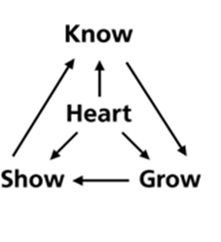

4 Ways

to Give **In Service**

*Boxes in Worship Center*

**Online**



*fellowshipwaco.org/giving*

**App**



*fellowshipwaco.org/app*

**Mail**

*P.O. Box 21655*

*Waco, TX 76702*

**How to Study Scripture: Learning from Ezra**

1. **Motivation: Desiring God**
2. **Investigation: Developing depth**

Observation – What is it saying?

Interpretation: What does It mean?

1. **Application: Demonstrating godliness Walk with God Using “PACES”**

**·P**rinciples to remember

**·A**ctions to take

**·C**onvictions to develop

**·E**xamples to follow

**·S**ins to confess

***Dwell on the goodness of God’s character to develop a lifestyle of knowing God’s word.***

**Everyone needs The Ezra Experience!**

Take Next



Steps **Membership**

*fellowshipwaco.org/membership*



**Serve**

*fellowshipwaco.org/serve*



**Small Groups**

*fellowshipwaco.org/groups*

***My personal application of this passage:***



**Video from previous messages: youtube.com/fellowshipwaco Audio from previous messages: fellowshipwaco.org/podcasts Sermon notes online: fellowshipwaco.org/sermon-notes**

**Questions for individual study and LIFE Groups:**

1. What daily patterns are shaping your spiritual life right now, and how do they reflect a heart set on knowing God?
2. In what specific ways can you “set your heart” in these next few months to know God more deeply through His word?
3. How have you seen God’s good hand guiding, providing, or sustaining you recently or in the past few years?.
4. What does it look like for you to live with a heart fully devoted to God in your current season of life?
5. What has been helpful to you in growing to know God and His word?