**August 17, 2025**

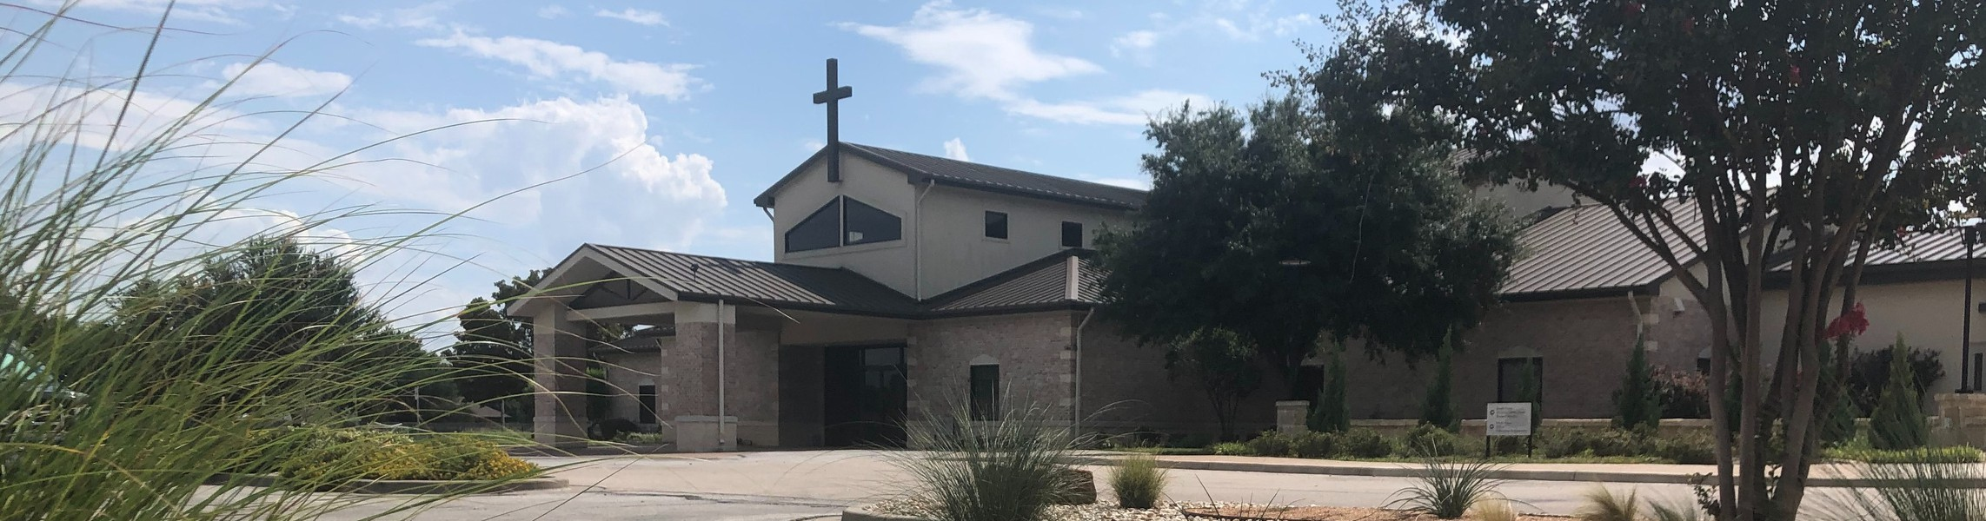

Welcome to Fellowship!

# Thank you for joining us for worship today! If you are a first-time visitor, please visit our Welcome Desk in the foyer or scan the QR code at right to complete a Guest Connect form.

Follow Us On Social Media

*@fellowshipwaco*

U P C O M I N G E V E N T S



**Need Assistance?**

Visit the South Foyer Welcome Desk and our friendly Welcome Team will be glad to answer any questions or help you find the information you’re looking for!

**Need Coffee?**

Visit our Café in the North Foyer. Our Hospitality Team is ready to serve you!

**Need Prayer?**

If you would like someone to pray with you, our Prayer Team is available at the back of the Worship Center after each service.

Visit our website:

fellowshipwaco.org

Email us: [office@fellowshipwaco.org](mailto:office@fellowshipwaco.org)

Read and subscribe to our weekly newsletter: fellowshipwaco.org

Download our church app: fellowshipwaco.org/app

Telephone: 254.848.7200

Tue. Wed. Sun. Sun. Sun.

Aug. 19

Aug. 20

Aug. 24

Aug. 24

Aug. 31

Student Ministry Parent Meeting Student Ministry Fall Kickoff School Outreach Interest Meeting Kids Ministry Volunteer Training Family Worship Sunday

**Fall Kickoff 2025 Bible Studies, Kids Ministry,**

**MomLIFE and more begin the week of Sept. 8!**

*For complete event details and registration, visit our website: fellowshipwaco.org/events*

*or scan the QR code at right.*

Good Morning Fellowship!

Why are you here on this earth? This morning, discover from Ezra’s life why studying and living God’s Word is directly related to our purpose in life and

how to make it part of your daily walk with God.

Grant Kaul, Senior Pastor

**T h e E z r a E x p e r i e n c e P a r t 2 :**

**S e t Y o u r H e a r t t o A p p l y G o d ’ s W o r d**

**E z r a 7 : 1 - 1 0**

**“Why am I here on this earth?”**

**Ezra in Context**

**Ezra 7:1-10**

**The Ezra Experience - The lifelong practice of life-giving believers is to intentionally pursue three priorities in response to the goodness of**

**God:**

1. **Know –** Study the word of God to deepen your **comprehension** and strengthen your **convictions.**
2. **Grow –** Apply and practice God’s word to shape your daily **conduct.**
3. **Show – Communicate** God’s truth by teaching it through your conversations, small group discussions, and public messages.



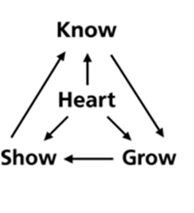

Here is a brief overview of **how Christian character is developed: Comprehension ** **Convictions Conduct**

4 Ways

to Give **In Service**

*Boxes in Worship Center*

**Online**



*fellowshipwaco.org/giving*

**App**



*fellowshipwaco.org/app*

**Mail**

*P.O. Box 21655*

*Waco, TX 76702*

**Walk with God Using “PACES”**

**·P**rinciples to remember

**·A**ctions to take

**·C**onvictions to develop

**·E**xamples to follow

**·S**ins to confess

**Ezra’s pattern mirrors Jesus’s call in John 14-15:**

*If you love Me, you will keep My commandments.*

John 14:15

*Jesus answered and said to him, ‘If anyone loves Me, he will keep My word; and My Father will love him, and We will come to him and make Our abode with him.*

John 14:23

**Applying the word of God in every aspect of our lives:**

1. **Personal Life 7:1-6, 10**
2. **Family Life 7:1-5**
3. **Work Life 7:6, 27-28**
4. **Ministry Life 7:10, 27-28; 9:4-6**

***The word of God is to become our way of life in Christ.***

Take Next



Steps **Membership**

*fellowshipwaco.org/membership*



**Serve**

*fellowshipwaco.org/serve*



**Small Groups**

*fellowshipwaco.org/groups*

***My personal application of this passage:***



**Video from previous messages: youtube.com/fellowshipwaco Audio from previous messages: fellowshipwaco.org/podcasts Sermon notes online: fellowshipwaco.org/sermon-notes**

**Questions for individual study and LIFE Groups:**

* 1. Where have you seen God’s good hand of guidance, provision, or protection lately?
  2. How are you learning to grow in “The Ezra Experience” of setting your heart to study and apply God’s word?
  3. Can you share a way you are learning to have the word of God become your way of life?
  4. What is a biblical worldview and how do Christians develop one?
  5. Ezra lived out his faith in his personal life, family life, work life, and ministry life. Which of these areas most needs renewed attention from you right now, and why is this important?