**August 24, 2025**

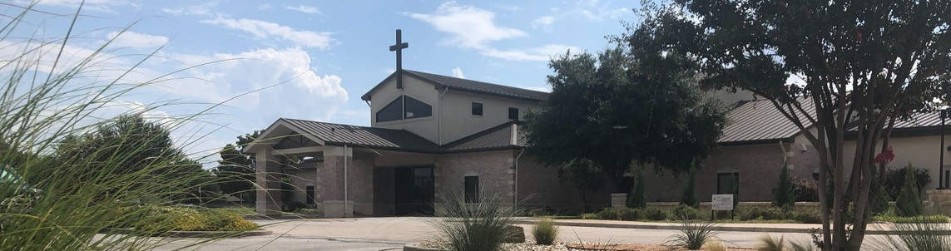

Welcome to Fellowship!

# Thank you for joining us for worship today! If you are a first-time visitor, please visit our Welcome Desk in the foyer or scan the QR code at right to complete a Guest Connect form.

Follow Us On Social Media

*@fellowshipwaco*

U P C O M I N G E V E N T S

Sun. Sun. Sun. Wed. Sun. Sun.

Sun. Sun. Sun. Tues. Wed. Wed. Wed. Wed.

Aug. 24

Aug. 24

Aug. 24

Aug. 27

Aug. 31

Aug. 31

Sept. 7

Sept. 7

Sept. 7

Sept. 9

Sept. 10

Sept. 10

Sept. 10

Sept. 10

School Outreach Interest Meeting Kids Ministry Volunteer Training Susan’s Retirement Celebration Student Ministry

Family Worship Sunday



**Need Assistance?**

Visit the South Foyer Welcome Desk and our friendly Welcome Team will be glad to answer any questions or help you find the information you’re looking for!

**Need Coffee?**

Visit our Café in the North Foyer. Our Hospitality Team is ready to serve you!

**Need Prayer?**

If you would like someone to pray with you, our Prayer Team is available at the back of the Worship Center after each service.

Visit our website:

fellowshipwaco.org

Email us: [office@fellowshipwaco.org](mailto:office@fellowshipwaco.org)

Read and subscribe to our weekly newsletter: fellowshipwaco.org

Download our church app: fellowshipwaco.org/app

Telephone: 254.848.7200

New Sermon Series - Philippians

ForeRunners Connection PLACE Class Foundations Class

Tuesday Morning Bible Studies Wednesday Night Bible Studies Student Ministry

Children’s Ministries - all ages GriefShare

Thurs. Sept. 11 Mom LIFE

*For complete event details and registration, visit our website: fellowshipwaco.org/events*

*or scan the QR code at right.*

Good Morning Fellowship!

Did you know that whatever fills your heart will eventually be manifested in your words? Jesus taught that when God’s Word fills us, His truth naturally flows from our mouths (Luke 6:45) whether in everyday conversations,

discipleship, small groups, or even public messages. This morning, we will

discover how The Ezra Experience culminates in communicating the word of God as a way of life.

Grant Kaul, Senior Pastor

**T h e E z r a E x p e r i e n c e P a r t 3 :**

**S e t Y o u r H e a r t t o C o m m u n i c a t e G o d ’ s W o r d**

**E z r a 7 : 1 - 1 0 / N e h e m i a h 8 : 1 - 1 2**

*The good man out of the good treasure of his heart brings forth what is good; and the evil man out of the evil treasure brings forth what is evil; for his mouth speaks from that which fills his heart.*

Luke 6:45

## The Ezra Experience - The lifelong practice of life-giving believers is to intentionally pursue three priorities:

1. **Know –** Study the word of God to deepen your **comprehension** and strengthen your **convictions.**
2. **Grow –** Apply and practice God’s word to shape your daily **conduct.**
3. **Show – Communicate** God’s truth by teaching it through your conversations, small group discussions, and public messages.

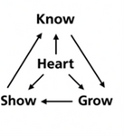

4 Ways

to Give **In Service**

*Boxes in Worship Center*

**Online**



*fellowshipwaco.org/giving*

**App**



*fellowshipwaco.org/app*

**Mail**

*P.O. Box 21655*

*Waco, TX 76702*

## There are a variety of ways of teaching God’s word:

1. Teaching by **example**
2. Personal **conversations**
3. **Discipleship** relationships

## Small group discussions

1. Public **messages**

## What are the essentials for becoming a strong communicator of God’s word?

|  |  |  |
| --- | --- | --- |
| **Foundation**  **·God’s word** |  | **7:6-10**  **v.6a** |
| **·God’s work**  God’s providential hand | vv.6,9 | **vv.6-10** |
| God’s prompting of the heart | v.7:10a |  |
| **Investigation** |  | **7:10** |
| **Application** |  | **7:10** |
| **Communication**  **·conversation** |  | **7:10** |

**·proclamation Nehemiah 8:1-12**

***When God’s word fills our hearts, His truth flows from our mouths.***

***The word of God is to become our way of life in Christ.***

Take Next



Steps **Membership**

*fellowshipwaco.org/membership*



**Serve**

*fellowshipwaco.org/serve*



**Small Groups**

*fellowshipwaco.org/groups*

***My personal application of this passage:***



**Video from previous messages: youtube.com/fellowshipwaco Audio from previous messages: fellowshipwaco.org/podcasts Sermon notes online: fellowshipwaco.org/sermon-notes**

**Questions for individual study and LIFE Groups:**

1. Luke 6:45 says, “The mouth speaks from that which fills the heart.” What are some things that tend to fill your heart and naturally come out in your words? How can you be more intentional about letting Scripture fill and be mentioned in your speech?
2. How do you see God’s Word producing understanding, conviction, and joy in Nehemiah 8:1-12, and how has the preaching and teaching of Scripture affected you at different times?
3. We communicate God’s Word in various ways, including through our conversations, discipleship relationships, ministry opportunities, and small group gatherings. Where do you currently have the most opportunity to share God’s Word with others?
4. What are two steps you can take this week to grow in your study, application, and communicating God’s word?
5. Think of someone in your life who needs encouragement. What is one specific verse, truth, or promise from Scripture you could share with them this week? How will you follow through?