**August 3, 2025**

Welcome to Fellowship!

# Thank you for joining us for worship today! If you are a first-time visitor, please visit our Welcome Desk in the foyer or scan the QR code at right to complete a Guest Connect form.

Follow Us On Social Media

*@fellowshipwaco*

U P C O M I N G E V E N T S

Sun. Sun. Sun. Wed. Wed. Sat. Sun. Sun. Thur. Thur. Sat.

Aug. 3

Aug. 3

Aug. 3

Aug. 6

Aug. 6

Aug. 9

Aug. 10

Aug. 10

Aug. 14

Aug. 14

Aug. 16

PLACE Class ForeRunners Connection

E3 Event with Baptisms @ 6PM Wednesday Evenings Bible Studies Student Ministry Water Wars LiveWires Family Pool Party Promotion Sunday!



**Need Assistance?**

Visit the South Foyer Welcome Desk and our friendly Welcome Team will be glad to answer any questions or help you find the information you’re looking for!

**Need Coffee?**

Visit our Café in the North Foyer. Our Hospitality Team is ready to serve you!

**Need Prayer?**

If you would like someone to pray with you, our Prayer Team is available at the back of the Worship Center after each service.

Visit our website:

fellowshipwaco.org

Email us: [office@fellowshipwaco.org](mailto:office@fellowshipwaco.org)

Read and subscribe to our weekly newsletter: fellowshipwaco.org

Download our church app: fellowshipwaco.org/app

Telephone: 254.848.7200

New Sermon Series - Ezra ForeRunners Ice Cream Social Church Office Closed

Men’s Breakfast

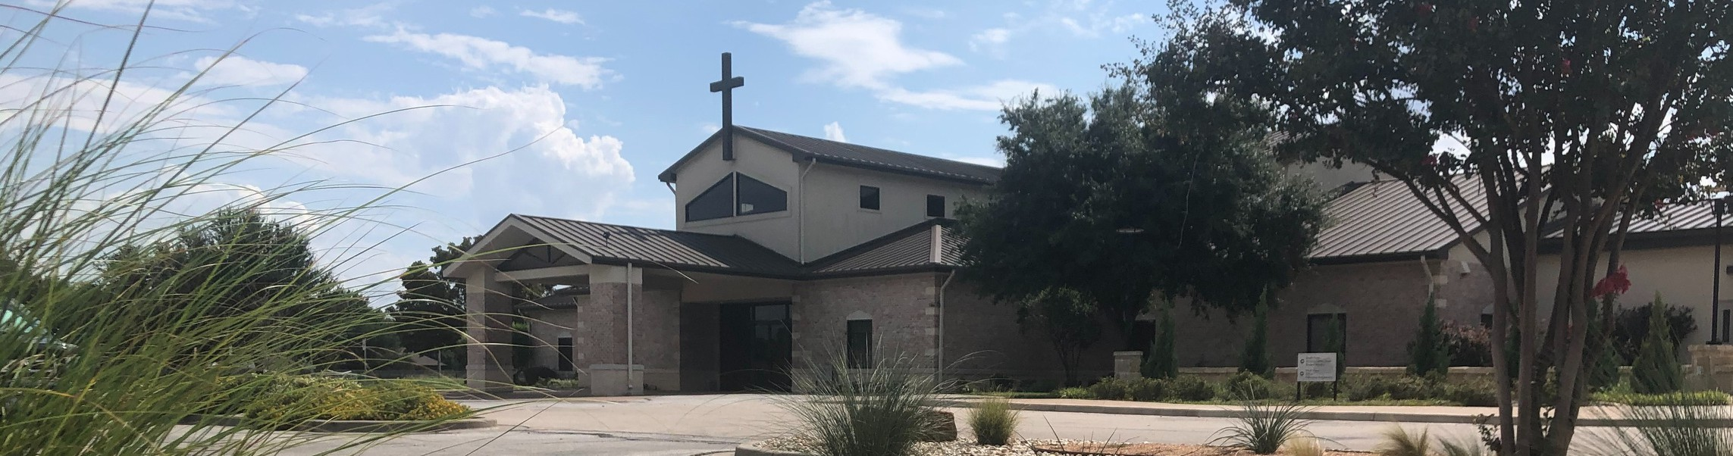

**Discover LIFE Membership Class Sunday Aug. 17 9am-12pm Register at fellowshipwaco.org**

*For complete event details and registration, visit our website: fellowshipwaco.org/events*

*or scan the QR code at right.*

Good Morning Fellowship!

Imagine a community so united in faith that it changes not just your life, but

the world around you—ready to discover how? This morning we will dive into Acts 2:41-42 to discover the vital role fellowship plays in unifying God’s

church. I can’t wait to worship with you!

George Ohmstede, Associate Pastor

**L I F E T o g e t h e r : T h e C a l l t o F e l l o w s h i p**

**A c t s 2 : 4 0 - 4 2**

**The**  **of the**  **.**

**The**  **of**  **.**

4 Ways

to Give **In Service**

*Boxes in Worship Center*

**Online**



*fellowshipwaco.org/giving*

**App**



*fellowshipwaco.org/app*

**Mail**

*P.O. Box 21655*

*Waco, TX 76702*

**The**  **of**  **.**

*Fellowship in*  *. Fellowship in*  *.*

*Fellowship in the*  *. Fellowship in*  *.*

**The**  **of**  **.**

*Loving God*

*Investing in Others Following His Word Engaging our world*

Take Next



Steps **Membership**

*fellowshipwaco.org/membership*



**Serve**

*fellowshipwaco.org/serve*



**Small Groups**

*fellowshipwaco.org/groups*

***My personal application of this passage:***



**Video from previous messages: youtube.com/fellowshipwaco Audio from previous messages: fellowshipwaco.org/podcasts Sermon notes online: fellowshipwaco.org/sermon-notes**

**Questions for individual study and LIFE Groups:**

1. How has the gospel personally transformed your understanding of fellowship, and what difference does it make in how you connect with others in your faith community?
2. In what practical ways can we prioritize devotion to God in our daily lives to strengthen our fellowship with other believers?
3. Break down the Potency of Fellowship in your own words. Research other scripture that speaks to each aspect. Discuss or journal the spiritual impact each aspect has had on you personally.
4. Which aspect of the LIFE Group purpose (Loving God, Investing in Others, Following His Word, Engaging our World) resonates most with you, and how can you live out this purpose more intentionally? (If in a LIFE Group, how can your LIFE Group do the same?)