**August 31, 2025**

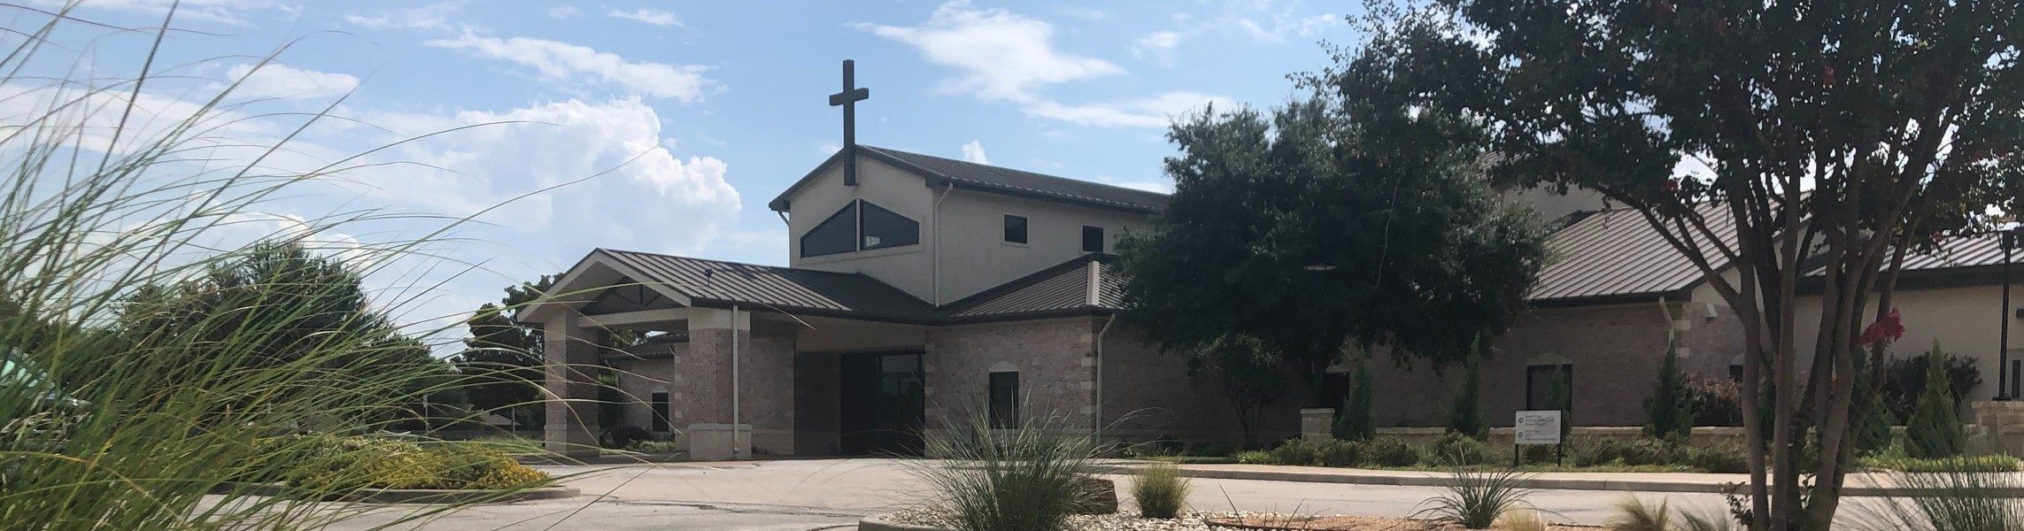

Welcome to Fellowship!

# Thank you for joining us for worship today! If you are a first-time visitor, please visit our Welcome Desk in the foyer or scan the QR code at right to complete a Guest Connect form.

Follow Us On Social Media

*@fellowshipwaco*

U P C O M I N G E V E N T S

Sun. Sun. Sun.

Mon. Wed. Sun. Sun. Sun. Tues. Wed. Wed. Wed. Wed.

Aug. 31

Aug. 31

Aug. 31

Sept. 1

Sept. 3

Sept. 7

Sept. 7

Sept. 7

Sept. 9

Sept. 10

Sept. 10

Sept. 10

Sept. 10

Family Worship Sunday Disaster Relief Interest Meeting

New Sermon Series - Philippians



**Need Assistance?**

Visit the South Foyer Welcome Desk and our friendly Welcome Team will be glad to answer any questions or help you find the information you’re looking for!

**Need Coffee?**

Visit our Café in the North Foyer. Our Hospitality Team is ready to serve you!

**Need Prayer?**

If you would like someone to pray with you, our Prayer Team is available at the back of the Worship Center after each service.

Visit our website:

fellowshipwaco.org

Email us: [office@fellowshipwaco.org](mailto:office@fellowshipwaco.org)

Read and subscribe to our weekly newsletter: fellowshipwaco.org

Download our church app: fellowshipwaco.org/app

Telephone: 254.848.7200

Labor Day - Church Office Closed Student Ministry

ForeRunners Connection PLACE Class Foundations Class

Tuesday Morning Bible Studies Wednesday Night Bible Studies Student Ministry

Children’s Ministries - all ages GriefShare

Thurs. Sept. 11 Mom LIFE

*For complete event details and registration, visit our website: fellowshipwaco.org/events*

*or scan the QR code at right.*

Good Morning Fellowship!

There is only one unshakable hope in this world: Jesus Christ, and the “good news” of all He has done, is doing, and will do. This morning, we begin our

new series in the Book of Philippians by looking to the first time the gospel of grace entered Europe and began transforming lives in the city of Philippi. For over 2,000 years, this same gospel has been changing lives, and it can

transform yours, too.

Grant Kaul, Senior Pastor

**G o d ’ s P o r t r a i t G a l l e r y o f t h e G o s p e l o f G r a c e**

**I n t r o d u c t i o n t o P h i l i p p i a n s**

**A c t s 1 6 : 6 - 4 0**

**the gospel:** the “good news” that by grace God forgives and redeems all who are broken over their sin and trust in Jesus Christ –

believing in His perfect life, substitutionary death, and resurrection. Through this salvation, He grants them

eternal life and calls them to follow Him as disciples in His kingdom*.*

**How does the gospel of Christ transform the people of the world?**

1. **The Gospel Matures Believers: Paul 16:6–12**
2. **The Gospel Opens Hearts: Lydia 16:13–15**

4 Ways

to Give **In Service**

*Boxes in Worship Center*

**Online**



*fellowshipwaco.org/giving*

**App**



*fellowshipwaco.org/app*

**Mail**

*P.O. Box 21655*

*Waco, TX 76702*

1. **The Gospel Liberates the Captive: A Spiritually-Oppressed**

**Slave Girl 16:16–24**

1. **The Gospel Strengthens Believers in Suffering: Paul & Silas 16:25**
2. **The Gospel Saves the Hopeless: The Philippian Jailer 16:25–40**

***Only the gospel of Christ can transform the people of the world.***

Take Next



Steps **Membership**

*fellowshipwaco.org/membership*



**Serve**

*fellowshipwaco.org/serve*



**Small Groups**

*fellowshipwaco.org/groups*

***My personal application of this passage:***



**Video from previous messages: youtube.com/fellowshipwaco Audio from previous messages: fellowshipwaco.org/podcasts Sermon notes online: fellowshipwaco.org/sermon-notes**

**Questions for individual study and LIFE Groups:**

* 1. When have you experienced a “closed door” that later proved to be God’s redirection, and how did it shape your trust in His timing and your maturity in following God’s direction?
  2. How does Lydia’s story of salvation demonstrate that success and influence don’t replace the need for Christ?
  3. How do we see the liberating power of Jesus Christ in Acts 16:14-18?
  4. When you face hardship, do you usually respond with complaining, despair, or worship? What would it look like for your suffering to become a testimony of joy to those around you?
  5. How does the story of the Philippian jailor in Acts 16:25-34 encourage you to believe that no one is beyond the reach of God’s grace?
  6. Looking at all the portraits in Acts 16, which one do you most relate to right now, and how is God displaying His grace in your life as part of His gospel gallery?