**September 14, 2025**

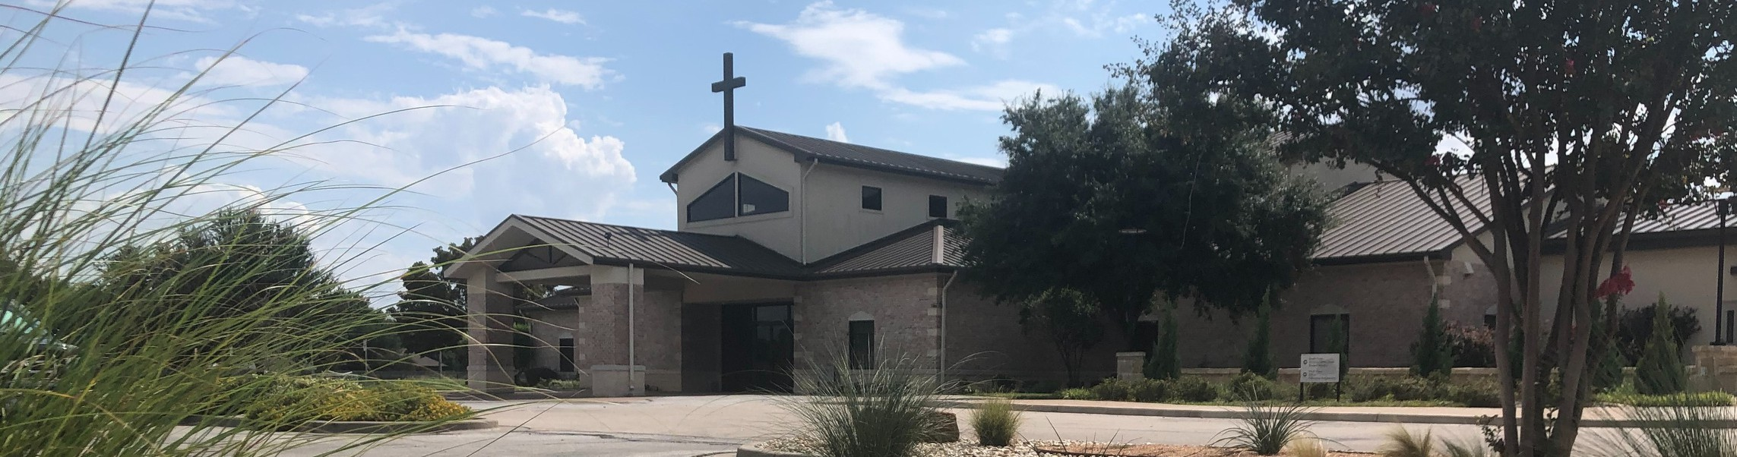

Welcome to Fellowship!

## Thank you for joining us for worship today! If you are a first-time visitor, please visit our Welcome Desk in the foyer or scan the QR code at right to complete a Guest Connect form.

Follow Us On Social Media

*@fellowshipwaco*

U P C O M I N G E V E N T S

Sun. Sun. Tues. Wed. Wed. Wed. Wed.

Sept. 14

Sept. 14

Sept. 16

Sept. 17

Sept. 17

Sept. 17

Sept. 17

PLACE Class Foundations Class

Tuesday Morning Bible Studies Wednesday Night Bible Studies Student Ministry



**Need Assistance?**

Visit the South Foyer Welcome Desk and our friendly Welcome Team will be glad to answer any questions or help you find the information you’re looking for!

**Need Coffee?**

Visit our Café in the North Foyer. Our Hospitality Team is ready to serve you!

**Need Prayer?**

If you would like someone to pray with you, our Prayer Team is available at the back of the Worship Center after each service.

Visit our website:

fellowshipwaco.org

Email us: [office@fellowshipwaco.org](mailto:office@fellowshipwaco.org)

Read and subscribe to our weekly newsletter: fellowshipwaco.org

Download our church app: fellowshipwaco.org/app

Telephone: 254.848.7200

Children’s Ministry - all ages GriefShare

Thurs. Sept. 18 MomLIFE

Sat. Sun. Sun. Sun.

Sept. 20

Sept. 21

Sept. 21

Sept. 21

Men’s Breakfast PLACE Class Foundations Class Church Picinc

*RSVP for the church picnic by scanning the QR code.*

Good Morning Fellowship!

How does “fellowship in the gospel” fuel the faith of God’s people? In

Philippians 1:12-18, the Apostle Paul highlights three ways our union with Christ, His people, and His mission bring about greater experiences and expressions of joy and faith in His people.

Grant Kaul, Senior Pastor

# H o w F e l l o w s h i p i n t h e G o s p e l F u e l s t h e F a i t h o f G o d ’ s P e o p l e

**P h i l i p p i a n s : T h e J o u r n e y o f J o y i n C h r i s t**

# P h i l i p p i a n s 1 : 1 2 - 1 8

**What does fellowship in the gospel produce?**

1. **God-centered approach to life 1:12-13**

How “fellowship in the gospel” can lead to a more God-centered life:

Put Christ at the center of your life

Turn your particular situation into a platform of proclamation

Bloom where you are planted

4 Ways

to Give **In Service**

*Boxes in Worship Center*

**Online**



*fellowshipwaco.org/giving*

**App**



*fellowshipwaco.org/app*

**Mail**

*P.O. Box 21655*

*Waco, TX 76702*

1. **Gospel-driven courage** **1:14**
2. **Grace-filled perspective to ministry 1:15-18**

***Fellowship in the gospel fuels the faith of God’s people.***

Take Next



Steps **Membership**

*fellowshipwaco.org/membership*



**Serve**

*fellowshipwaco.org/serve*



**Small Groups**

*fellowshipwaco.org/groups*

***My personal application of this passage:***



**Video from previous messages: youtube.com/fellowshipwaco Audio from previous messages: fellowshipwaco.org/podcasts Sermon notes online: fellowshipwaco.org/sermon-notes**

**Questions for individual study, small group Bible studies, and LIFE Groups:**

* 1. When life feels unfair or overwhelming, how can Paul’s example of asking “How can this be fruitful for Christ?” (instead of “Why me?”) reshape the way you respond to trials?
  2. What circumstance in your life right now, whether responsibilities, limitations, or hardships, could God be using as a platform for the gospel? How might you view them differently in light of Paul’s perspective?
  3. Paul’s courage in prison stirred courage in others. Who has inspired you by the way they faced hardship, and how can your own response to trials help strengthen the faith of those around you?
  4. Why do you think opposition from fellow believers often hurts more than opposition from unbelievers? How can Paul’s response in verses 15–18 help us guard against bitterness when that happens?
  5. Paul rejoiced that “Christ is preached” even when people had wrong motives. What does this teach us about focusing on the message rather than the messenger, and how might Paul’s mindset shape the way we handle criticism?
  6. Fellowship and “participation in the gospel” (1:5) mean we are not spectators but partners in Christ’s mission. What practical steps can you take this week to encourage others in our church or community to grow in boldness, joy, and Christ-centered perseverance?