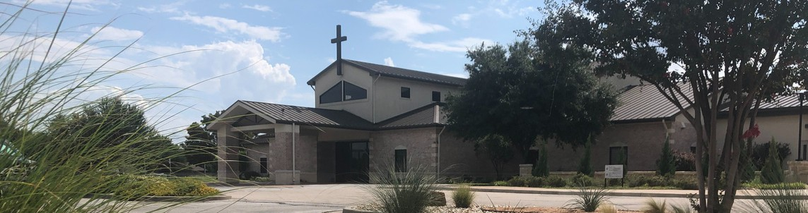



September 21, 2025

Welcome to Fellowship!

Thank you for joining us for worship today! If you are a first-time visitor, please visit our Welcome Desk in the foyer or scan the QR code at right to complete a Guest Connect form.

Follow Us On Social Media

@fellowshipwaco

U P C O M I N G E V E N T S

Sun. Sun. Sun. Tues. Wed. Wed. Wed. Thur. Sun. Sun. Tues. Wed. Wed. Wed. Thur.
Sept. 21
Sept. 21
Sept. 21
Sept. 23
Sept. 24
Sept. 24
Sept. 24
Sept. 25
Sept. 28
Sept. 28
Sept. 30
Oct. 1
Oct. 1
Oct. 1
Oct. 2
Spanish Class Foundations Class Church Picinc



Tuesday Morning Bible Studies Wednesday Night Bible Studies Student Ministry
Need Assistance?
Visit the South Foyer Welcome Desk and our friendly Welcome Team will be glad to answer any questions or help you find the information you’re looking for!

Need Coffee?
Visit our Café in the North Foyer. Our Hospitality Team is ready to serve you!

Need Prayer?
If you would like someone to pray with you, our Prayer Team is available at the back of the Worship Center after each service.

Visit our website:
fellowshipwaco.org
Email us: office@fellowshipwaco.org
Read and subscribe to our weekly newsletter: fellowshipwaco.org
Download our church app: fellowshipwaco.org/app
Telephone: 254.848.7200
Children’s Ministry - all ages MomLIFE
Spanish Class Foundations Class
Tuesday Morning Bible Studies Wednesday Night Bible Studies Student Ministry
Children’s Ministry - all ages MomLIFE

For complete event details and registration, visit our website: fellowshipwaco.org/events
or scan the QR code at right.

Good Morning Fellowship!

“To live is Christ and to die is gain.” This is such a powerful promise and
truth. This morning we will continue our series, “The Journey of Joy in Christ,” by exploring the depth of joy this passage provides. I can’t wait to worship
with you!

George Ohmstede, Associate Pastor

H o w D o B e l i e v e r s B e c o m e H e a v e n l y M i n d e d f o r G r e a t e r E a r t h l y G o o d ?
P h i l i p p i a n s : T h e J o u r n e y o f J o y i n C h r i s t

P h i l i p p i a n s 1 : 1 8 b - 3 0

1) We are in Christ’s

4 Ways
to Give In Service
Boxes in Worship Center


Online
fellowshipwaco.org/giving

App
fellowshipwaco.org/app

Mail
P.O. Box 21655
Waco, TX 76702

- We are to Christ’s

Components of the mission:

Living out the mission:
Conduct in a manner of the gospel!


Take Next
Steps Membership
fellowshipwaco.org/membership


Serve
fellowshipwaco.org/serve


Small Groups
fellowshipwaco.org/groups


My personal application of this passage:
Video from previous messages: youtube.com/fellowshipwaco Audio from previous messages: fellowshipwaco.org/podcasts Sermon notes online: fellowshipwaco.org/sermon-notes

Questions for individual study, small group Bible studies, and LIFE Groups:

  - In what area of your life do you need to replace fear or discouragement with confidence in Christ’s power? How can prayer and the Holy Spirit’s help strengthen you in this pursuit?

  - What are some practical ways you can magnify Christ in your workplace, home, our church, or friendships this week?

  - If you were to answer this question before you became a believer, “For me, to live is ,” what would you have written? How has your response to this question been developing this year?

  - Where might God be calling you to put aside personal comfort or preference in order to serve and strengthen others in their faith?

  - How should remembering that your citizenship is in heaven shape your daily priorities, decisions, and relationships here on earth?

  - How can we encourage each other to stand firm and show courage when following Christ brings misunderstanding, ridicule, or hardship?

