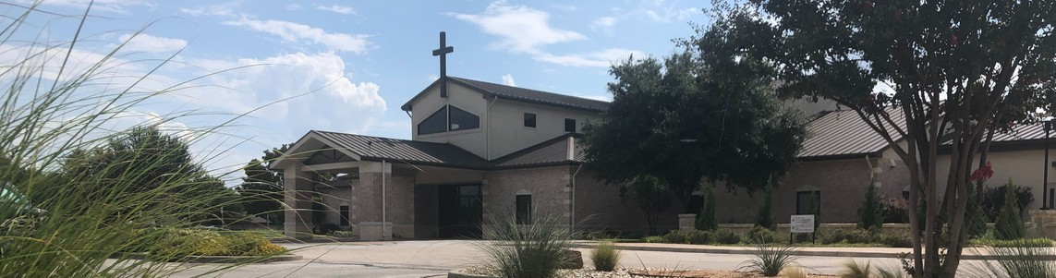



September 28, 2025

Welcome to Fellowship!

Thank you for joining us for worship today! If you are a first-time visitor, please visit our Welcome Desk in the foyer or scan the QR code at right to complete a Guest Connect form.

Follow Us On Social Media

@fellowshipwaco

U P C O M I N G E V E N T S




For complete event details and registration, visit our website: fellowshipwaco.org/events
Need Assistance?
Visit the South Foyer Welcome Desk and our friendly Welcome Team will be glad to answer any questions or help you find the information you’re looking for!

Need Coffee?
Visit our Café in the North Foyer. Our Hospitality Team is ready to serve you!

Need Prayer?
If you would like someone to pray with you, our Prayer Team is available at the back of the Worship Center after each service.

Visit our website:
fellowshipwaco.org
Email us: office@fellowshipwaco.org
Read and subscribe to our weekly newsletter: fellowshipwaco.org
Download our church app: fellowshipwaco.org/app
Telephone: 254.848.7200
Sun. | Sept. 28 | Spanish Bible Study
Sun. | Sept. 28 | Foundations Class
Tues. | Sept. 30 | Tuesday Morning Bible Studies
Wed. | Oct. 1 | Wednesday Night Bible Studies
Wed. | Oct. 1 | Student Ministry
Wed. | Oct. 1 | Children’s Ministry - all ages
Thur. | Oct. 2 | MomLIFE
Sun. | Oct. 5 | Spanish Bible Study
Sun. | Oct. 5 | Foundations Class
Sun. | Oct. 5 | ForeRunners Connection
Wed. | Oct. 8 | Women’s Prayer Group
Thur. | Oct. 9 | ForeRunners OCC Packing Party
Sat. | Oct. 11 | LiveWires Event
Thur. | Oct. 16 | Ladies Night Out
Sun. | Oct. 19 | Discover LIFE Membership Class
Sun. | Oct. 26 | Baptism Sunday

or scan the QR code at right.

Good Morning Fellowship!

Have you ever asked, “What does it mean to make much of Jesus?” In Philippians 2:1–11, Paul offers one of the most practical and profound
passages in Scripture, illustrating both the humility and exaltation of Christ and the mindset every believer must adopt to live for His glory.
Grant Kaul, Pastor

T h e J o y o f M a k i n g M u c h o f J e s u s
P h i l i p p i a n s : T h e J o u r n e y o f J o y i n C h r i s t

P h i l i p p i a n s 2 : 1 - 1 1

How do I make much of Jesus?

How do believers in Jesus Christ make much of Him? The mindset for making much of Jesus:
- Be invigorated by His presence 2:1

4 Ways  to Give In Service
Boxes in Worship Center


Online
fellowshipwaco.org/giving

App
fellowshipwaco.org/app

Mail
P.O. Box 21655
Waco, TX 76702

- Be intent on His purpose 2:2-4

- Be impassioned by His personhood 2:5-11

The joy of making much of Jesus is at the heart of a Christ-centered life.


Take Next
Steps Membership
fellowshipwaco.org/membership


Serve
fellowshipwaco.org/serve


Small Groups
fellowshipwaco.org/groups


My personal application of this passage:
Video from previous messages: youtube.com/fellowshipwaco Audio from previous messages: fellowshipwaco.org/podcasts Sermon notes online: fellowshipwaco.org/sermon-notes

Questions for individual study, small group Bible studies, and LIFE Groups:

  - What are some ways you can daily “recharge” your soul in Christ’s presence so that you live by His power and not your own?

  - Paul reminds believers of the encouragement, love, fellowship, and compassion that are already theirs in Christ. How do these spiritual realities provide practical strength when you face discouragement, temptation, or relational strain?

  - What attitudes or habits of selfish ambition and conceit can subtly creep into your life or your church, and how can humility redirect your focus toward Christ’s mission?

  - How can our group, ministry, or church practically demonstrate being “one- souled” and “intent on one purpose” in glorifying Christ and advancing the gospel together?

  - When you think about Jesus’ humility in becoming human and dying on the cross, how does that shape your attitude toward obedience, service, and suffering in your own life?

  - Paul said, “For to me, to live is Christ and to die is gain” (Phil. 1:21), and he highlights that our words and way of life are to rejoice in the fact that Jesus Christ is Lord as presented in Philippians 2:1-11. What does it look like for you, in your daily routines, relationships, ministry, and/or work, to live with the goal of making much of Jesus?

