**September 7, 2025**

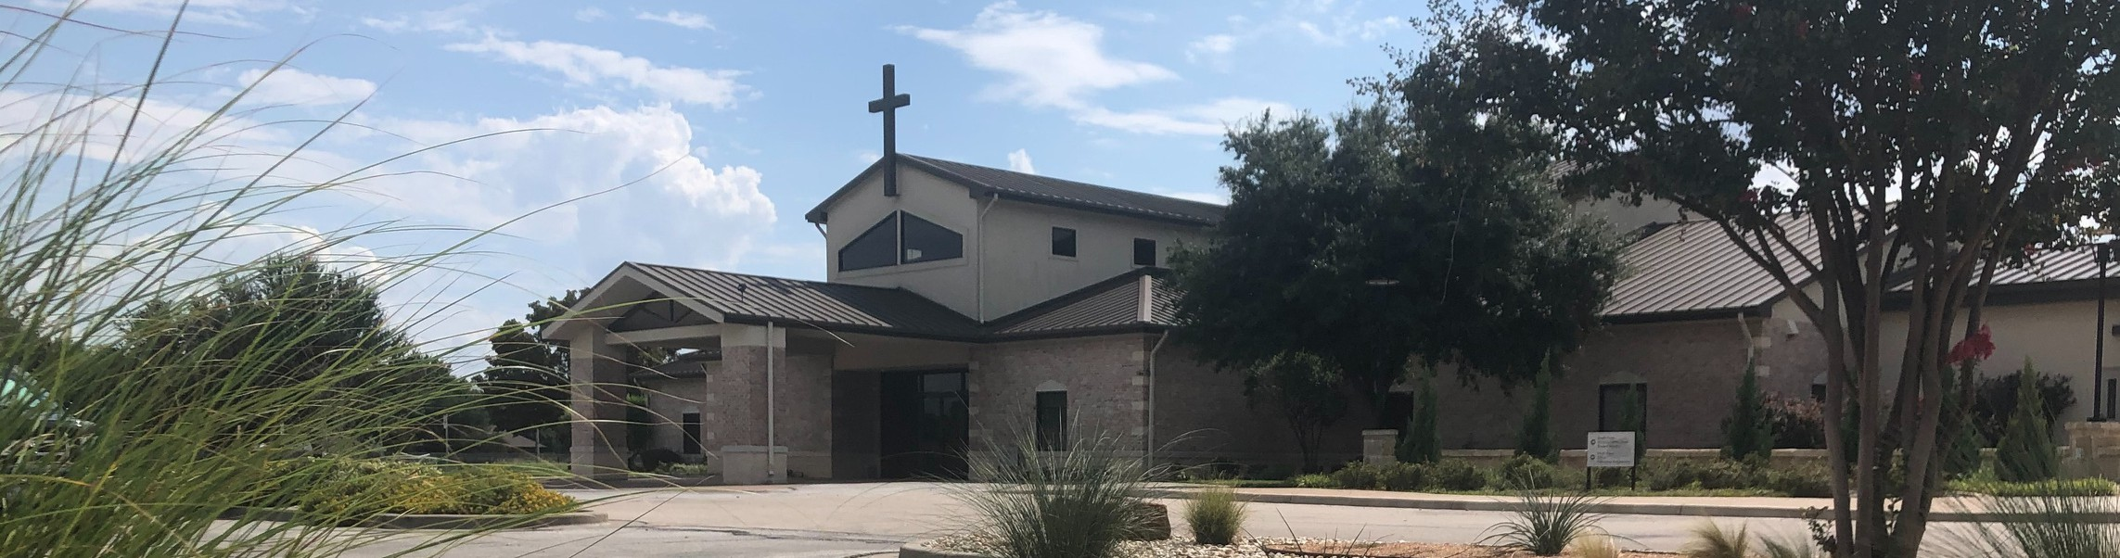

Welcome to Fellowship!

# Thank you for joining us for worship today! If you are a first-time visitor, please visit our Welcome Desk in the foyer or scan the QR code at right to complete a Guest Connect form.

Follow Us On Social Media

*@fellowshipwaco*

U P C O M I N G E V E N T S

Sun. Sun. Sun. Tues. Wed. Wed. Wed. Wed.

Sept. 7

Sept. 7

Sept. 7

Sept. 9

Sept. 10

Sept. 10

Sept. 10

Sept. 10

ForeRunners Connection PLACE Class begins Foundations Class begins Tuesday Morning Bible Studies

Wednesday Night Bible Studies Student Ministry



**Need Assistance?**

Visit the South Foyer Welcome Desk and our friendly Welcome Team will be glad to answer any questions or help you find the information you’re looking for!

**Need Coffee?**

Visit our Café in the North Foyer. Our Hospitality Team is ready to serve you!

**Need Prayer?**

If you would like someone to pray with you, our Prayer Team is available at the back of the Worship Center after each service.

Visit our website:

fellowshipwaco.org

Email us: [office@fellowshipwaco.org](mailto:office@fellowshipwaco.org)

Read and subscribe to our weekly newsletter: fellowshipwaco.org

Download our church app: fellowshipwaco.org/app

Telephone: 254.848.7200

Children’s Ministries - all ages GriefShare begins

Thurs. Sept. 11

Thurs. Sept. 11

Mom LIFE begins

ForeRunners Field Trip to Clifton

Sat.

Sept. 20

Men’s Breakfast

*For complete event details and registration, visit our website: fellowshipwaco.org/events*

*or scan the QR code at right.*

**T h e K e y T h a t O p e n s t h e D o o r t o J o y**

Good Morning Fellowship!

Every heart longs for joy, but so few truly experience it. In his Letter to the

Philippians, the Apostle Paul reveals the key that unlocks lasting joy, and he shares it right in the opening verses. This morning, we’ll discover the joy of knowing Jesus in the journey of life.

Grant Kaul, Senior Pastor

**P h i l i p p i a n s : T h e J o u r n e y o f J o y i n C h r i s t**

**P h i l i p p i a n s 1 : 1 - 1 1**

**How can a person truly come to know joy?**

***Our fellowship in the gospel leads to experiencing and expressing joy in Christ.***

**How does fellowship in the gospel bring joy to believers?**

**Fellowship in the gospel brings the following experiences of joy in believers:**

1. **Gratitude to God 1:1–5**

4 Ways

to Give **In Service**

*Boxes in Worship Center*

**Online**



*fellowshipwaco.org/giving*

**App**



*fellowshipwaco.org/app*

**Mail**

*P.O. Box 21655*

*Waco, TX 76702*

**the gospel:** the “good news” that by grace God forgives and redeems all who are broken over their sin and trust in Jesus Christ –

believing in His perfect life, substitutionary death, and resurrection. Through this salvation, He grants them

eternal life and calls them to follow Him as disciples in His kingdom*.*

1. **Confidence in God** **1:6**
2. **Love for people and their growth 1:7–11**

***Our fellowship in the gospel leads to experiencing and expressing joy in Christ.***

Take Next



Steps **Membership**

*fellowshipwaco.org/membership*



**Serve**

*fellowshipwaco.org/serve*



**Small Groups**

*fellowshipwaco.org/groups*

***My personal application of this passage:***



**Video from previous messages: youtube.com/fellowshipwaco Audio from previous messages: fellowshipwaco.org/podcasts Sermon notes online: fellowshipwaco.org/sermon-notes**

**Questions for individual study, small group Bible studies, and LIFE Groups:**

* 1. Who has God placed in your life to strengthen your relationship with Christ, and how might you express gratitude to God for them and encourage them this week?
  2. How are you growing in your fellowship in the gospel, both in your personal relationship with Jesus Christ and with fellow believers, as emphasized in Philippians 1:5?
  3. In what areas of your life do you need to renew your trust in God’s ongoing work, and how does Philippians 1:6 give you confidence in Him and a joy in Christ?
  4. Why is it important that believers grow in their ability to love others, as we see in Philippians 1:7-8? In what ways are you learning how to love like this?
  5. Can you share a few ways you are growing in knowledge and discernment, and how this is expressed in your decisions, relationships, and priorities (see vv. 9-11)?
  6. How do you see God producing the “fruit of righteousness” such as Spirit-led attitudes, God-honoring actions, and Christ-centered relationships (see vv. 9-11)?