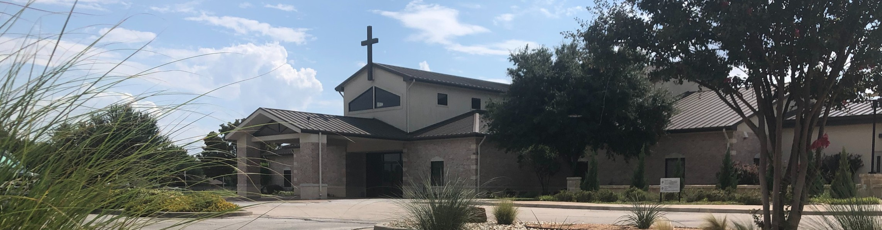



October 19, 2025

Welcome to Fellowship!

Thank you for joining us for worship today! If you are a first-time visitor, please visit our Welcome Desk in the foyer or scan the QR code at right to complete a Guest Connect form.

Follow Us On Social Media

@fellowshipwaco

U P C O M I N G E V E N T S

Sun. Sun. Sun. Tues. Wed. Wed. Wed. Wed. Thur. Sun.
Oct. 19
Oct. 19
Oct. 19
Oct. 21
Oct. 22
Oct. 22
Oct. 22
Oct. 22
Oct. 23
Oct. 26
Discover LIFE Membership Class Spanish Bible Study Foundations Class



Tuesday Morning Bible Studies Women’s Prayer Group Wednesday Night Bible Studies Student Ministry
Need Assistance?
Visit the South Foyer Welcome Desk and our friendly Welcome Team will be glad to answer any questions or help you find the information you’re looking for!

Need Coffee?
Visit our Café in the North Foyer. Our Hospitality Team is ready to serve you!

Need Prayer?
If you would like someone to pray with you, our Prayer Team is available at the back of the Worship Center after each service.

Visit our website:
fellowshipwaco.org
Email us: office@fellowshipwaco.org
Read and subscribe to our weekly newsletter: fellowshipwaco.org
Download our church app: fellowshipwaco.org/app
Telephone: 254.848.7200
Children’s Ministry - all ages MomLIFE
Baptism Sunday

For complete event details and registration, visit our website: fellowshipwaco.org/events
or scan the QR code at right.

Good Morning Fellowship!
Every person’s life tells a story, but the real question is what shapes that story. Our world trains us to believe that identity is built by achievements, credentials, or status, and many spend their lives trying to build a résumé that proves their worth. Philippians 3:1–11 confronts that illusion by showing that when someone truly encounters Jesus Christ, He transforms them into something entirely new.
Grant Kaul, Pastor

L i f e S t o r y : H o w R e l a t i o n s h i p w i t h C h r i s t T r a n s f o r m s t h e S t o r y o f Y o u r L i f e
P h i l i p p i a n s : T h e J o u r n e y o f J o y i n C h r i s t

P h i l i p p i a n s 3 : 1 - 1 1

How does a relationship with Jesus Christ transform the story of a person’s life?

Relationship with Christ gives believers the following:

- A new perspective on our past: Confident only in Christ 3:1-8

4 Ways
to Give In Service
Boxes in Worship Center


Online
fellowshipwaco.org/giving

App
fellowshipwaco.org/app

Mail
P.O. Box 21655
Waco, TX 76702

- A new position from our God: Made righteous in Christ 3:9

- A new passion for our lives: Knowing Christ fully 3:10-11

The joy of a relationship with Jesus gives us a new perspective on our past, a new position from our God, and a new passion for our lives.


Take Next
Steps Membership
fellowshipwaco.org/membership


Serve
fellowshipwaco.org/serve


Small Groups
fellowshipwaco.org/groups


My personal application of this passage:
Video from previous messages: youtube.com/fellowshipwaco Audio from previous messages: fellowshipwaco.org/podcasts Sermon notes online: fellowshipwaco.org/sermon-notes

Questions for individual study, small group Bible studies, and LIFE Groups:

  - Where are you most tempted to place your confidence -- your background, behavior, or achievements, and how does Philippians 3 reshape that perspective? What does it look like to treat those things as “loss” compared to knowing Christ?

  - How does “rejoicing in the Lord” by cultivating and expressing delight and confidence in who Christ is and what He has done feature in your life? How have you experienced “rejoicing in the Lord” as a guardrail for your soul?

  - Paul describes believers as those who “worship in the Spirit, glory in Christ, and put no confidence in the flesh.” How are you growing in these areas?

  - What does it mean in Philippians 3:9 for you to receive “through faith in Jesus Christ the righteousness which comes from God on the basis of faith?” How does this gospel truth develop confidence in God and your love for Christ?

  - Paul’s goal was not merely to know about Christ, but to know Him relationally and experientially. What rhythms or habits in your life deepen your relationship and fellowship with Him?

  - How have you seen the “power of His resurrection” or “the fellowship of His sufferings” at work in your life recently?

