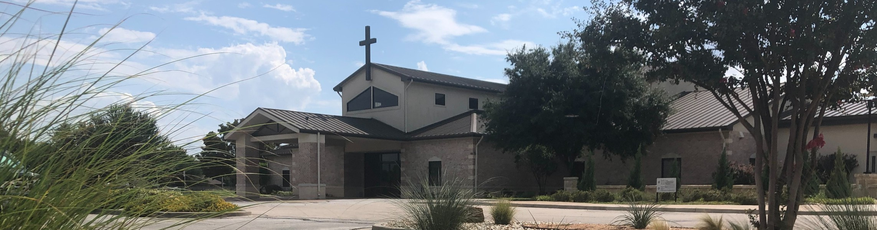



October 5, 2025

Welcome to Fellowship!

Thank you for joining us for worship today! If you are a first-time visitor, please visit our Welcome Desk in the foyer or scan the QR code at right to complete a Guest Connect form.

Follow Us On Social Media

@fellowshipwaco

U P C O M I N G E V E N T S




For complete event details and registration, visit our website: fellowshipwaco.org/events
Need Assistance?
Visit the South Foyer Welcome Desk and our friendly Welcome Team will be glad to answer any questions or help you find the information you’re looking for!

Need Coffee?
Visit our Café in the North Foyer. Our Hospitality Team is ready to serve you!

Need Prayer?
If you would like someone to pray with you, our Prayer Team is available at the back of the Worship Center after each service.

Visit our website:
fellowshipwaco.org
Email us: office@fellowshipwaco.org
Read and subscribe to our weekly newsletter: fellowshipwaco.org
Download our church app: fellowshipwaco.org/app
Telephone: 254.848.7200
Sun. | Oct. 5 | Spanish Bible Study
Sun. | Oct. 5 | Foundations Class
Sun. | Oct. 5 | ForeRunners Connection
Tues. | Oct. 7 | Tuesday Morning Bible Studies
Wed. | Oct. 8 | Women’s Prayer Group
Wed. | Oct. 8 | Wednesday Night Bible Studies
Wed. | Oct. 8 | Student Ministry
Wed. | Oct. 8 | Children’s Ministry - all ages
Thur. | Oct. 9 | MomLIFE
Thur. | Oct. 9 | ForeRunners OCC Packing Party
Sat. | Oct. 11 | LiveWires Event
Thur. | Oct. 16 | Ladies Night Out
Sat. | Oct. 18 | Men’s Work Day
Sun. | Oct. 19 | Discover LIFE Membership Class
Sun. | Oct. 26 | Baptism Sunday

or scan the QR code at right.

Good Morning Fellowship!

Have you ever felt stuck in your walk with Christ, as if you’re not growing as you had hoped? Whether you feel like you’re floundering or flourishing,
Philippians 2:12–18 shows us what every believer needs. In this passage, Paul reveals how to live out our faith as those who are united with Christ.
Grant Kaul, Pastor

H o w T h e n S h a l l W e L i v e ?
P h i l i p p i a n s : T h e J o u r n e y o f J o y i n C h r i s t

P h i l i p p i a n s 2 : 1 2 - 1 8

How then shall we live as people united with the resurrected Lord Jesus Christ?

We live with a new priority: Mining the riches of salvation 2:12

4 Ways  to Give In Service
Boxes in Worship Center


Online
fellowshipwaco.org/giving

App
fellowshipwaco.org/app

Mail
P.O. Box 21655
Waco, TX 76702

We live with a new power: Thriving in relationship with God 2:13

“But by the grace of God I am what I am, and His grace toward me did not prove vain; but I labored even more than all of them, yet not I, but the grace
of God with me.”
1 Corinthians 15:10

“We proclaim Him, admonishing every man and teaching every man with all wisdom, so that we may present every man complete in Christ. For this
purpose also I labor, striving according to His power, which mightily works within me.”
Colossians 1:28–29

We live with a new purpose: Shining as lights in the world 2:14–18

We shine the light of Christ as we live out our faith in Christ.


Take Next
Steps Membership
fellowshipwaco.org/membership


Serve
fellowshipwaco.org/serve


Small Groups
fellowshipwaco.org/groups


My personal application of this passage:
Video from previous messages: youtube.com/fellowshipwaco Audio from previous messages: fellowshipwaco.org/podcasts Sermon notes online: fellowshipwaco.org/sermon-notes

Questions for individual study, small group Bible studies, and LIFE Groups:

  - Paul commands us to “work out” our salvation, not “work for” it. The original word conveys the sense of mining out treasures that are already within. What “treasures of salvation” has God already deposited in your life, and what practices help you draw them out and develop Christlikeness day by day?

  - How can cultivating a holy reverence for God (“fear and trembling”) change the way we approach daily decisions, relationships, or struggles with sin?

  - Philippians 2:13 says God is the one “who is at work in you, both to will and to work for His good pleasure.” How have you seen God energize both your desires and your actions in recent months? What would change in your life if you truly trusted that His Spirit is empowering you right now?

  - Why do you think Paul makes such a strong point about doing “all things without grumbling or disputing” (v. 14)? How does complaining damage both our personal witness and the unity of the church?

  - What practical habits help you to “hold fast” to God’s Word so that it fuels your life like a wick fuels a flame? What simple steps can you take this week to deepen your intake and application of Scripture?

  - Paul describes his life as a drink offering poured out for others (vv. 17–18). What does it mean for us to pour out our lives for God’s people joyfully? How can we encourage one another to see sacrificial service as gain, not loss, and the path to true joy?

