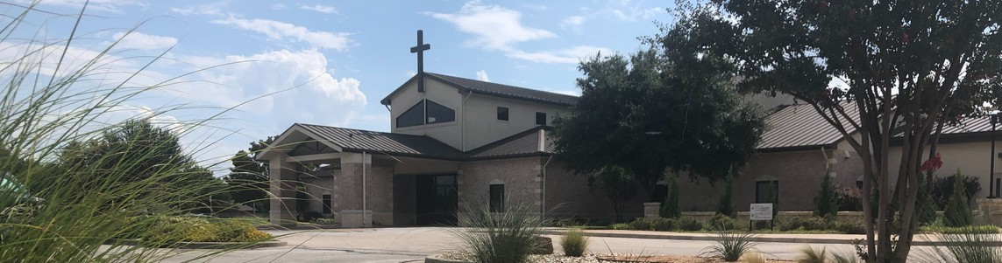



November 16, 2025

Welcome to Fellowship!

Thank you for joining us for worship today! If you are a first-time visitor, please visit our Welcome Desk in the foyer or scan the QR code at right to complete a Guest Connect form.

Follow Us On Social Media

@fellowshipwaco

U P C O M I N G E V E N T S

Sun. Sun. Sun. Sun. Tues. Wed. Wed. Wed. Wed. Thur. Sun. Sun. Sun.
Nov. 16
Nov. 16
Nov. 16
Nov. 16
Nov. 18
Nov. 19
Nov. 19
Nov. 19
Nov. 19
Nov. 20
Nov. 23
Nov. 23
Nov. 23
Spanish Bible Study Foundations Class



Marriage Seminar - Part One OCC Shoebox Collection Begins Tuesday Morning Bible Studies Women’s Prayer Group Wednesday Night Bible Studies Student Ministry
Need Assistance?
Visit the South Foyer Welcome Desk and our friendly Welcome Team will be glad to answer any questions or help you find the information you’re looking for!

Need Coffee?
Visit our Café in the North Foyer. Our Hospitality Team is ready to serve you!

Need Prayer?
If you would like someone to pray with you, our Prayer Team is available at the back of the Worship Center after each service.

Visit our website:
fellowshipwaco.org
Email us: office@fellowshipwaco.org
Read and subscribe to our weekly newsletter: fellowshipwaco.org
Download our church app: fellowshipwaco.org/app
Telephone: 254.848.7200
Children’s Ministry - all ages MomLIFE
Spanish Bible Study Foundations Class
Marriage Seminar - Part Two

For complete event details and registration, visit our website: fellowshipwaco.org/events
or scan the QR code at right.

Good Morning Fellowship!
What if the greatest joy is not found in what you keep but in what you give? In Philippians 4:15–23, Paul celebrates a church whose open hands and open hearts became channels of God’s grace. When God’s generosity flows through us, both others and we ourselves thrive in the joy of generous living.
Grant Kaul, Pastor

T h e J o y o f G e n e r o u s L i v i n g
P h i l i p p i a n s : T h e J o u r n e y o f J o y i n C h r i s t

P h i l i p p i a n s 4 : 1 5 - 2 3

How to experience the joy of generous living:

- Treasure the fellowship in the gospel of God as your delight 4:15-18

4 Ways
to Give In Service
Boxes in Worship Center


Online
fellowshipwaco.org/giving

App
fellowshipwaco.org/app

Mail
P.O. Box 21655
Waco, TX 76702

- Treasure the guarantee of God as your peace 4:19

- Treasure the glory of God as your goal 4:20-23

We know the joy of generous living
as we become pipelines of God’s grace.


Take Next
Steps Membership
fellowshipwaco.org/membership


Serve
fellowshipwaco.org/serve


Small Groups
fellowshipwaco.org/groups


My personal application of this passage:
Video from previous messages: youtube.com/fellowshipwaco Audio from previous messages: fellowshipwaco.org/podcasts Sermon notes online: fellowshipwaco.org/sermon-notes

Questions for individual study, small group Bible studies, and LIFE Groups:

- Where do you see God using your resources, time, or abilities to strengthen His work in others, and how might He be calling you to expand this partnership in the gospel (see 1:5; 4:15)?

- The Philippians supported gospel work “once and again.” What habits or changes would help you practice generosity that is regular and intentional rather than occasional or reactive?

- Paul said their generosity produced “fruit that increased to their account.” How does remembering the eternal impact of giving change the way you view your finances and priorities?

- God promises to supply every need “according to His riches in glory in Christ Jesus.” How does that truth challenge your view of security, comfort, or financial fear?

- The gospel reached even into Caesar’s household because of the Philippians’ generosity. Where might God be using your giving to reach people you may never personally see or meet?

- What blessings, privileges, or resources has God poured into your life this season, and what is one practical way you could allow those blessings to flow outward to someone else?

