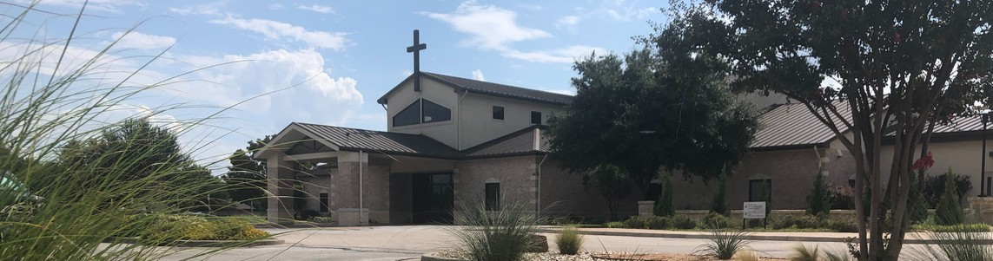



February 1, 2026

Welcome to Fellowship!

Thank you for joining us for worship today! If you are a first-time visitor, please visit our Welcome Desk in the foyer or scan the QR code at right to complete a Guest Connect form.

Follow Us On Social Media

@fellowshipwaco

U P C O M I N G E V E N T S

Sun. Sun. Sun. Tues. Wed. Wed. Wed. Wed. Thur. Sat.
Feb. 1
Feb. 1
Feb. 1
Feb. 3
Feb. 4
Feb. 4
Feb. 4
Feb. 4
Feb. 5
Feb. 7
Spanish Bible Study Foundations Class ForeRunners Connection Adult Bible Studies Adult Bible Studies GriefShare



Fellowship Kids Ministry Student-Catalyst Session 1 MomLIFE
Need Assistance?
Visit the South Foyer Welcome Desk and our friendly Welcome Team will be glad to answer any questions or help you find the information you’re looking for!

Need Coffee?
Visit our Café in the North Foyer. Our Hospitality Team is ready to serve you!

Need Prayer?
If you would like someone to pray with you, our Prayer Team is available at the back of the Worship Center after each service.

Visit our website:
fellowshipwaco.org
Email us: office@fellowshipwaco.org
Read and subscribe to our weekly newsletter: fellowshipwaco.org
Download our church app: fellowshipwaco.org/app
Telephone: 254.848.7200
LiveWires Valentine Dinner


Scan to register for the Date Night on Feb. 13!

For complete event details and registration, visit our website: fellowshipwaco.org/events
or scan the QR code at right.

Good Morning Fellowship!
Are you searching for hope? In a world where “hope” is one of the most searched words online, God offers something far deeper and more lasting than wishful thinking: a living hope through Jesus Christ. This morning, we will look at 1 Peter 1:3–5 and discover the unshakable hope God gives that transforms our lives from the inside out.
Grant Kaul, Senior Pastor

L i v i n g H o p e

1 P e t e r 1 : 3 - 5

Are you searching for hope?

What is the living hope God gives to His people?
- God gives new life in Christ 1:3

4 Ways  to Give In Service
Boxes in Worship Center


Online
fellowshipwaco.org/giving

App
fellowshipwaco.org/app

Mail
P.O. Box 21655
Waco, TX 76702

- God gives a new future in heaven 1:4

- God gives a new confidence in the present 1:5

We live in hope by treasuring the living hope of Christ.


Take Next
Steps Membership
fellowshipwaco.org/membership


Serve
fellowshipwaco.org/serve


Small Groups
fellowshipwaco.org/groups


My personal application of this passage:
Video from previous messages: youtube.com/fellowshipwaco Audio from previous messages: fellowshipwaco.org/podcasts Sermon notes online: fellowshipwaco.org/sermon-notes

Questions for individual study, small group Bible studies, and LIFE Groups:

  - How would you describe the difference between biblical hope and the kind of hope our world usually talks about? Where are you most tempted to look for hope apart from Christ?

  - What fears, anxieties, or uncertainties are you carrying right now that reveal you may be relying more on yourself than on God’s power? What would it look like to consciously place those in God’s hands this week?

  - How does truly believing that your future is secure in heaven change the way you face suffering, loss, or disappointment today? Where do you most need that eternal perspective right now?

  - What past failure, present pain, or future fear most tries to define you? How does God’s promise of new life, a secure future, and present protection speak directly to a past failure, present pain, or future fear?

  - Who in your life right now seems to be searching for hope, and how could you intentionally point them to Christ this week through your words or actions? What is one practical step you could take?

