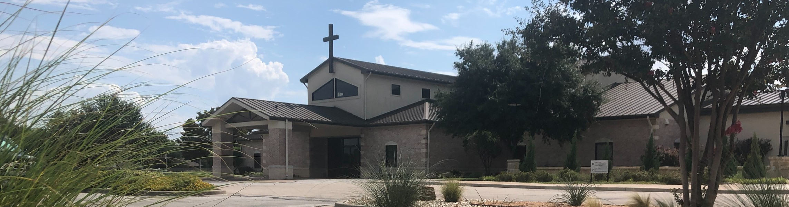



February 15, 2026

Welcome to Fellowship!

Thank you for joining us for worship today! If you are a first-time visitor, please visit our Welcome Desk in the foyer or scan the QR code at right to complete a Guest Connect form.

Follow Us On Social Media

@fellowshipwaco

U P C O M I N G E V E N T S

Sun. Sun. Sun. Sun. Tues. Wed. Wed. Wed. Wed. Thur. Thur. Fri.
Feb. 15
Feb. 15
Feb. 15
Feb. 15
Feb. 17
Feb. 18
Feb. 18
Feb. 18
Feb. 18
Feb. 19
Feb. 20
Feb. 21
Spanish Bible Study Foundations Class Equipped for LIFE Catalyst



Adult Bible Studies Fellowship Kids Ministry Adult Bible Studies GriefShare
Need Assistance?
Visit the South Foyer Welcome Desk and our friendly Welcome Team will be glad to answer any questions or help you find the information you’re looking for!

Need Coffee?
Visit our Café in the North Foyer. Our Hospitality Team is ready to serve you!

Need Prayer?
If you would like someone to pray with you, our Prayer Team is available at the back of the Worship Center after each service.

Visit our website:
fellowshipwaco.org
Email us: office@fellowshipwaco.org
Read and subscribe to our weekly newsletter: fellowshipwaco.org
Download our church app: fellowshipwaco.org/app
Telephone: 254.848.7200
Student-Reach MomLIFE
Men’s Conference Men’s Conference


Scan to sign up for baptisms NEXT Sunday!

For complete event details and registration, visit our website: fellowshipwaco.org/events
or scan the QR code at right.

Good Morning Fellowship!
Have you ever trusted Christ yet longed for a deeper sense of awe over His gift of salvation? In 1 Peter 1:10–12, we are reawakened to its greatness and renewed to live lives gripped by grace.
Grant Kaul, Senior Pastor

G r i p p e d b y G r a c e :
L i v i n g i n A w e o f O u r G r e a t S a l v a t i o n

1 P e t e r 1 : 1 0 - 1 2

Three truths that renew our awe for the greatness of our salvation:

- The gospel of our salvation was predicted by the prophets
1:10-12a

4 Ways
to Give In Service
Boxes in Worship Center


Online
fellowshipwaco.org/giving

App
fellowshipwaco.org/app

Mail
P.O. Box 21655
Waco, TX 76702

- The gospel of our salvation is proclaimed by believers 1:12b

“For truly I say to you that many prophets and righteous men desired to see what you see, and did not see it, and to hear what you hear,
and did not hear it.”
Matthew 13:17

- The gospel of our salvation is prized by angels 1:12c

“In the same way, I tell you, there is joy in the presence of the angels of God over one sinner who repents.”
Luke 15:10

As we grow in awe of our great salvation, our lives become gripped by grace.


Take Next
Steps Membership
fellowshipwaco.org/membership


Serve
fellowshipwaco.org/serve


Small Groups
fellowshipwaco.org/groups


My personal application of this passage:
Video from previous messages: youtube.com/fellowshipwaco Audio from previous messages: fellowshipwaco.org/podcasts Sermon notes online: fellowshipwaco.org/sermon-notes

Questions for individual study, small group Bible studies, and LIFE Groups:

  - Where have you noticed yourself drifting into “spiritual autopilot,” and what has that done to your sense of wonder over God’s grace? What practices help you stay spiritually alert and grateful?

  - How does knowing that God planned your salvation long before you were born affect the way you view your worth, struggles, and future?

  - Who played a key role in bringing the gospel into your life, and how does their faithfulness challenge you to pass it on? Who might God be calling you to intentionally influence right now?

  - If angels marvel at God’s work in your life, what does that say about how seriously you should take your walk with Christ?

  - What would change in your daily life to live “gripped by grace” this week at home, at work, at school, and in your relationships? What is one specific step you can take to live that out?

