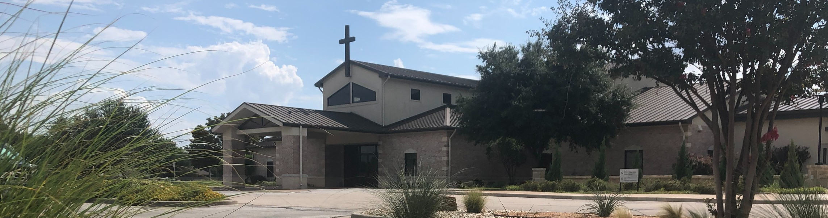



March 1, 2026

Welcome to Fellowship!

Thank you for joining us for worship today! If you are a first-time visitor, please visit our Welcome Desk in the foyer or scan the QR code at right to complete a Guest Connect form.

Follow Us On Social Media

@fellowshipwaco

U P C O M I N G E V E N T S

Sun. Sun. Sun. Suns. Sun. Sun. Tues. Tues. Wed. Wed. Wed. Wed. Thur. Sun. Sun.
Mar. 1
Mar. 1
Mar. 1
Mar. 1
Mar. 1
Mar. 1
Mar. 3
Mar. 3
Mar. 4
Mar. 4
Mar. 4
Mar. 4
Mar. 5
Mar. 8
Mar. 8
Spanish Bible Study Foundations Class Equipped for LIFE Milestone 1 - Session Two ForeRunners Connection



18/24 Young Adults Meeting Election Day
Need Assistance?
Visit the South Foyer Welcome Desk and our friendly Welcome Team will be glad to answer any questions or help you find the information you’re looking for!

Need Coffee?
Visit our Café in the North Foyer. Our Hospitality Team is ready to serve you!

Need Prayer?
If you would like someone to pray with you, our Prayer Team is available at the back of the Worship Center after each service.

Visit our website:
fellowshipwaco.org
Email us: office@fellowshipwaco.org
Read and subscribe to our weekly newsletter: fellowshipwaco.org
Download our church app: fellowshipwaco.org/app
Telephone: 254.848.7200
Adult Bible Studies Fellowship Kids Ministry Student-Reach
Adult Bible Studies GriefShare MomLIFE
Family Worship Sunday Daylight Saving Time Begins

For complete event details and registration, visit our website: fellowshipwaco.org/events
or scan the QR code at right.

Good Morning Fellowship!
Would you like to know the secret for unshakable hope? The answer lies within 1 Peter 1:17-21. This morning, we will unlock this secret and gain deeper understanding of how unshakable hope begins with a reverent fear, a redeeming faith, and a resurrection foundation! I can’t wait to worship together!
George Ohmstede, Associate Pastor

A L I F E L i v e d w i t h F e a r , R e d e m p t i o n a n d U n s h a k a b l e H o p e !

1 P e t e r 1 : 1 7 - 2 1

Three key truths to know so you may live with an unshakable hope!

- in our early exile v.17

4 Ways
to Give In Service
Boxes in Worship Center


Online
fellowshipwaco.org/giving

App
fellowshipwaco.org/app

Mail
P.O. Box 21655
Waco, TX 76702

by Christ’s blood vv. 18-19

- for faith and hope vv. 20-21


Take Next
Steps Membership
fellowshipwaco.org/membership


Serve
fellowshipwaco.org/serve


Small Groups
fellowshipwaco.org/groups


My personal application of this passage:
Video from previous messages: youtube.com/fellowshipwaco Audio from previous messages: fellowshipwaco.org/podcasts Sermon notes online: fellowshipwaco.org/sermon-notes

Questions for individual study, small group Bible studies, and LIFE Groups:

- What does “reverent fear” look like in your daily life? How might viewing God as both loving Father and righteous Judge change the way you approach obedience, decisions, or even small habits?

- From what “meaningless patterns” of your past has Christ redeemed you? Google the lyrics to the old hymn “There is Power in the Blood” and read or sing them. Reflect on the power of Christ’s unblemished and spotless blood and how it washes us white as snow!

- How do fear (awe/respect) and gratitude for redemption work together in a healthy Christian life? Can you share a time when remembering your redemption helped you overcome temptation or complacency, or when fear of displeasing God motivated positive change?

- How does the reality of Christ’s resurrection and pre-planned redemption give you “unshakable hope” amid current challenges or uncertainties? In what areas of life do you need to more fully place your confident expectation in God alone?

- Which of these three aspects —fear, redemption, or hope—resonates most strongly with you right now, and why?

