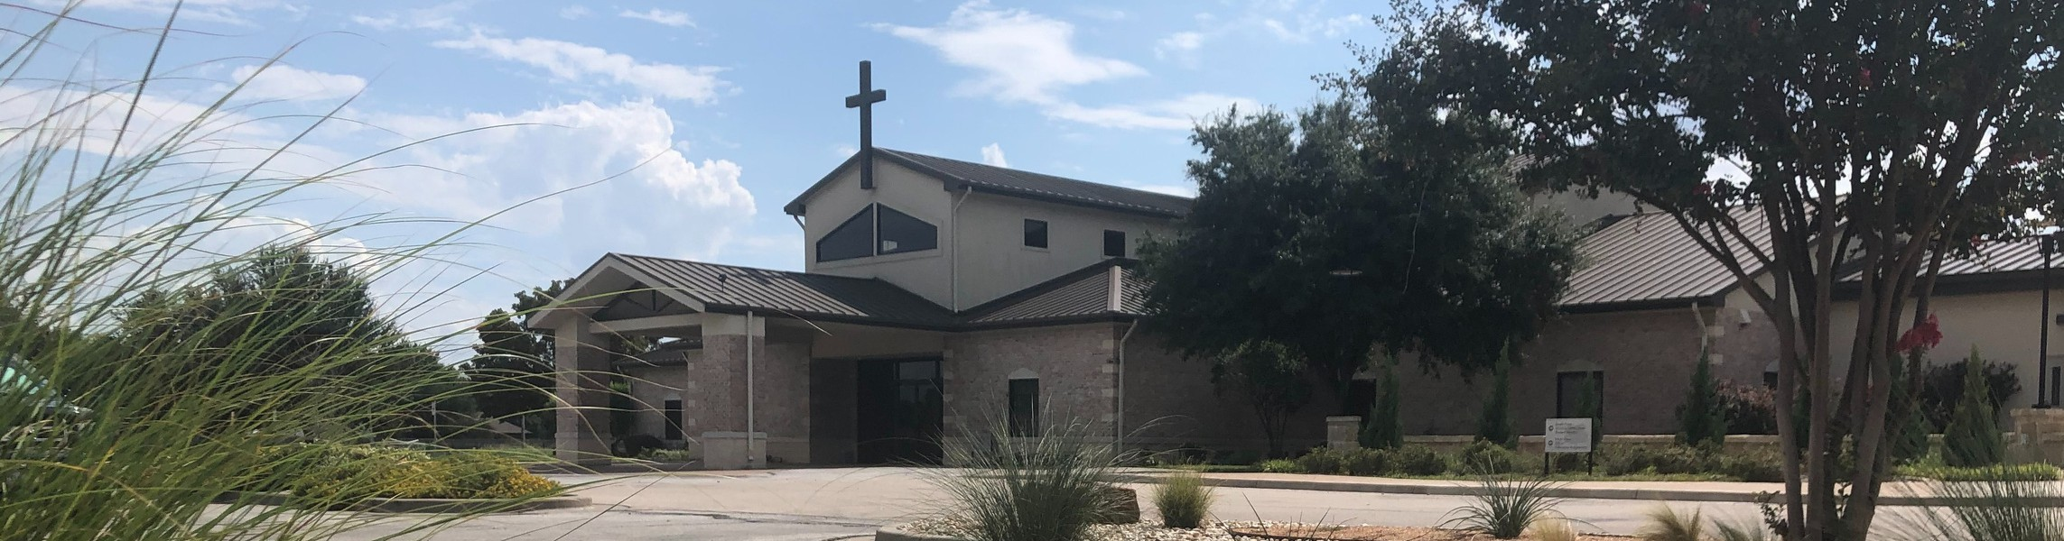



March 22, 2026

Welcome to Fellowship!

Thank you for joining us for worship today! If you are a first-time visitor, please visit our Welcome Desk in the foyer or scan the QR code at right to complete a Guest Connect form.

Follow Us On Social Media

@fellowshipwaco

U P C O M I N G E V E N T S

Sun. Sun. Sun. Sun. Tues. Wed. Wed. Wed. Wed. Thur. Sat.
Mar. 22
Mar. 22
Mar. 22
Mar. 22
Mar. 24
Mar. 25
Mar. 25
Mar. 25
Mar. 25
Mar. 26
Mar. 28
Frontier Camp in Foyer Spanish Bible Study Foundations Class Equipped for LIFE Adult Bible Studies



Fellowship Kids Ministry Student-Reach
Need Assistance?
Visit the South Foyer Welcome Desk and our friendly Welcome Team will be glad to answer any questions or help you find the information you’re looking for!

Need Coffee?
Visit our Café in the North Foyer. Our Hospitality Team is ready to serve you!

Need Prayer?
If you would like someone to pray with you, our Prayer Team is available at the back of the Worship Center after each service.

Visit our website:
fellowshipwaco.org
Email us: office@fellowshipwaco.org
Read and subscribe to our weekly newsletter: fellowshipwaco.org
Download our church app: fellowshipwaco.org/app
Telephone: 254.848.7200
Adult Bible Studies GriefShare MomLIFE
Student Worship & Serve Night

TODAY ONLY!!!
Student Ministry fundraiser at Raising Cane’s, 1501 Hewitt Drive 12:00-5:00 p.m.
Mention the fundraiser at the register!
For complete event details and registration, visit our website: fellowshipwaco.org/events
or scan the QR code at right.

Good Morning Fellowship!
Every life is being built on something. In 1 Peter 2:4-8, we discover why Jesus Christ is called the cornerstone and why our response to Him determines the foundation and destiny of our lives. This morning, we are exploring the most important question every person must answer.

Grant Kaul, Senior Pastor

I s C h r i s t Y o u r C o r n e r s t o n e ?

1 P e t e r 2 : 4 - 8

Is Jesus Christ your cornerstone for life?

Two truths every person needs to know about Jesus Christ:

- Trusting Christ leads to eternal life and worship with His people
2:4-7a

He is the stone which was rejected by you, the builders, but which became the chief corner stone. And there is salvation in no one else; for there is no other
name under heaven that has been given among men by which we must be saved.
Acts 4:11–12

4 Ways
to Give In Service
Boxes in Worship Center


Online
fellowshipwaco.org/giving

App
fellowshipwaco.org/app

Mail
P.O. Box 21655
Waco, TX 76702

- Rejecting Christ Leads to eternal judgment 2:7b–8

For the word of the cross is foolishness to those who are perishing, but to us who are being saved it is the power of God.
1 Corinthians 1:18

Is Jesus Christ your cornerstone for life?

How are you building your life upon Him today?

Our response to the Cornerstone of Christ reveals
whether we truly have an eternal foundation for our lives.


Take Next
Steps Membership
fellowshipwaco.org/membership


Serve
fellowshipwaco.org/serve


Small Groups
fellowshipwaco.org/groups


My personal application of this passage:
Video from previous messages: youtube.com/fellowshipwaco Audio from previous messages: fellowshipwaco.org/podcasts Sermon notes online: fellowshipwaco.org/sermon-notes

Questions for individual study, small group Bible studies, and LIFE Groups:

- What does your daily life look like in practice when Christ is your cornerstone rather than just an important part of your life?

- In what areas of your life are you most tempted to align with something other than Christ as your reference point?

- How have you experienced God shaping or refining you through difficult circumstances as part of His building process?

- What does it mean for you to live not as an isolated believer but as a living stone connected to others in the church?

- How does your current response to Jesus show whether He is the foundation in your life?

