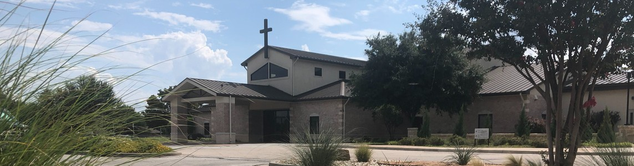



March 29, 2026

Welcome to Fellowship!

Thank you for joining us for worship today! If you are a first-time visitor, please visit our Welcome Desk in the foyer or scan the QR code at right to complete a Guest Connect form.

Follow Us On Social Media

@fellowshipwaco

U P C O M I N G E V E N T S

Sun. Sun. Sun. Tues. Wed. Wed. Wed. Wed. Thur. Fri.
Mon.
Mar. 29
Mar. 29
Mar. 29
Mar. 31
Apr. 1
Apr. 1
Apr. 1
Apr. 1
Apr. 2
Apr. 3
Apr. 6
Spanish Bible Study Foundations Class Equipped for LIFE Adult Bible Studies



Fellowship Kids Ministry Student-Reach
Need Assistance?
Visit the South Foyer Welcome Desk and our friendly Welcome Team will be glad to answer any questions or help you find the information you’re looking for!

Need Coffee?
Visit our Café in the North Foyer. Our Hospitality Team is ready to serve you!

Need Prayer?
If you would like someone to pray with you, our Prayer Team is available at the back of the Worship Center after each service.

Visit our website:
fellowshipwaco.org
Email us: office@fellowshipwaco.org
Read and subscribe to our weekly newsletter: fellowshipwaco.org
Download our church app: fellowshipwaco.org/app
Telephone: 254.848.7200
Adult Bible Studies GriefShare MomLIFE
Good Friday - Office Closed Office Closed

GOOD FRIDAY & EASTER SUNDAY
Good Friday family worship service at 6:30 p.m.
No childcare.
Easter Sunrise at 7:30 a.m. - no childcare Easter 9:00 a.m. - Kids Ministry birth-4th grade Easter 10:45 a.m. - Kids Ministry birth-6th grade
For complete event details and registration, visit our website: fellowshipwaco.org/events
or scan the QR code at right.

Good Morning Fellowship!
Once we were not a people, but now we are God’s people—called out of darkness and into His marvelous light. Each day we have the opportunity to carry living hope into a hopeless world. This morning, we celebrate what it means to live as People of Living Hope.

Curtis Fahrlender, Associate Pastor

A P e o p l e o f L i v i n g H o p e :
C a l l e d O u t o f D a r k n e s s i n t o H i s M a r v e l o u s L i g h t

1 P e t e r 2 : 9 - 1 0

Our Identity in Christ v. 9a

- Our Purpose in Christ v. 9b

4 Ways
to Give In Service
Boxes in Worship Center


Online
fellowshipwaco.org/giving

App
fellowshipwaco.org/app

Mail
P.O. Box 21655
Waco, TX 76702

Our Testimony in Christ v. 10


Take Next
Steps Membership
fellowshipwaco.org/membership


Serve
fellowshipwaco.org/serve


Small Groups
fellowshipwaco.org/groups


My personal application of this passage:
Video from previous messages: youtube.com/fellowshipwaco Audio from previous messages: fellowshipwaco.org/podcasts Sermon notes online: fellowshipwaco.org/sermon-notes

Questions for individual study, small group Bible studies, and LIFE Groups:

  - What are some practical ways you can “proclaim His excellencies” this week—at home, work, school?

  - When fear or anxiety feels overwhelming, how can remembering that God has called you “out of darkness into His marvelous light” bring hope and stability?

  - How can your “darkness to light” testimony offer living hope to someone struggling?

  - Peter reminds us that we have received mercy. How can gratitude influence your interactions with other people this week?

