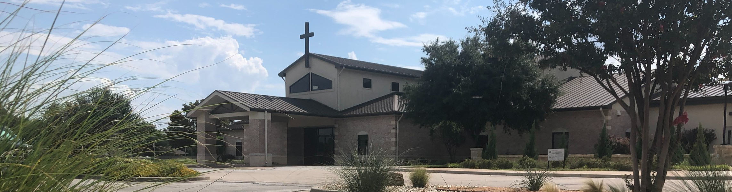



March 8, 2026

Welcome to Fellowship!

Thank you for joining us for worship today! If you are a first-time visitor, please visit our Welcome Desk in the foyer or scan the QR code at right to complete a Guest Connect form.

U P C O M I N G E V E N T S

Follow Us On Social Media

@fellowshipwaco

Sun. Sun. Sun. Sun. Wed. Thur.
Mar. 8
Mar. 8
Mar. 8
Mar. 8
Mar. 11
Mar. 12
Spanish Bible Study Foundations Class Equipped for LIFE Family Worship Sunday GriefShare



ForeRunners Lunch
Need Assistance?
Visit the South Foyer Welcome Desk and our friendly Welcome Team will be glad to answer any questions or help you find the information you’re looking for!

Need Coffee?
Visit our Café in the North Foyer. Our Hospitality Team is ready to serve you!

Need Prayer?
If you would like someone to pray with you, our Prayer Team is available at the back of the Worship Center after each service.

Visit our website:
fellowshipwaco.org
Email us: office@fellowshipwaco.org
Read and subscribe to our weekly newsletter: fellowshipwaco.org
Download our church app: fellowshipwaco.org/app
Telephone: 254.848.7200

Today is Family Worship. All children and students will be in the Worship Center.
Due to Spring Break, all Tuesday, Wednesday and Thursday ministries will not meet.

For complete event details and registration, visit our website: fellowshipwaco.org/events
or scan the QR code at right.

Good Morning Fellowship!
How does the word of God move from something we occasionally read to the very way we live? In 1 Peter 1:22–25, we discover how the living and enduring word of God takes root in our hearts and produces lasting spiritual growth. This morning, we will learn how God’s Word becomes our way of life.
Grant Kaul, Senior Pastor

H o w t h e W o r d o f G o d
B e c o m e s o u r W a y o f L I f e

1 P e t e r 1 : 2 2 - 2 5

How does the Word of God become our way of life?

- Trust His truth to purify your soul 1:22

“He who believes in the Son has eternal life; but he who does not obey the Son will not see life, but the wrath of God abides on him.”

John 3:36

So faith comes from hearing, and hearing by the word of Christ.

Romans 10:17

4 Ways
to Give In Service
Boxes in Worship Center


Online
fellowshipwaco.org/giving

App
fellowshipwaco.org/app

Mail
P.O. Box 21655
Waco, TX 76702

Treasure His word to transform your life 1:22-25

“What We Believe About the Bible” article at LivingOutLIFE.org:

https://www.livingoutlife.org/the-principles-of-spiritual-maturity-unit-11/


The word of God becomes our way of life as we trust it and treasure it in our hearts.

God’s revelation brings transformation.


Take Next
Steps Membership
fellowshipwaco.org/membership


Serve
fellowshipwaco.org/serve


Small Groups
fellowshipwaco.org/groups


My personal application of this passage:
Video from previous messages: youtube.com/fellowshipwaco Audio from previous messages: fellowshipwaco.org/podcasts Sermon notes online: fellowshipwaco.org/sermon-notes

Questions for individual study, small group Bible studies, and LIFE Groups:

  - What role does obedience to God’s Word play in purifying your heart and shaping how you live?

  - Who in your life right now may need the kind of sincere and fervent love Peter describes in this passage?

  - What attitudes or habits can hinder God’s Word from taking deeper root in your heart and relationships?

  - In what practical ways can you treasure and prioritize the Word of God in your daily life this week?

  - How have you personally seen God’s Word take root and produce growth or change in your life over time?

