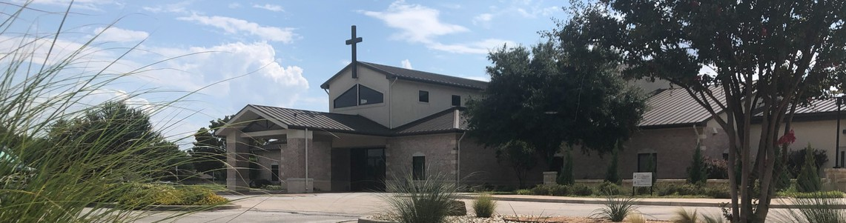



April 12, 2026

Welcome to Fellowship!

Thank you for joining us for worship today! If you are a first-time visitor, please visit our Welcome Desk in the foyer or scan the QR code at right to complete a Guest Connect form.

Follow Us On Social Media

@fellowshipwaco

U P C O M I N G E V E N T S

Sun. Sun. Sun. Sun. Tues. Wed. Wed. Wed. Wed. Thur. Sat. Sat. Sun. Sun.
Apr. 12
Apr. 12
Apr. 12
Apr. 12
Apr. 14
Apr. 15
Apr. 15
Apr. 15
Apr. 15
Apr. 16
Apr. 18
Apr. 18
Apr. 19
Apr. 26
Spanish Bible Study Foundations Class Equipped for LIFE 18/24 Group Adult Bible Studies



Fellowship Kids Ministry Student-Reach
Need Assistance?
Visit the South Foyer Welcome Desk and our friendly Welcome Team will be glad to answer any questions or help you find the information you’re looking for!

Need Coffee?
Visit our Café in the North Foyer. Our Hospitality Team is ready to serve you!

Need Prayer?
If you would like someone to pray with you, our Prayer Team is available at the back of the Worship Center after each service.

Visit our website:
fellowshipwaco.org
Email us: office@fellowshipwaco.org
Read and subscribe to our weekly newsletter: fellowshipwaco.org
Download our church app: fellowshipwaco.org/app
Telephone: 254.848.7200
Adult Bible Studies GriefShare MomLIFE
Men’s Breakfast LiveWires Event
Discover LIFE Membership Class Baptism Sunday

For complete event details and registration, visit our website: fellowshipwaco.org/events
or scan the QR code at right.

Good Morning Fellowship!
In a world where compromise is common and convictions are constantly tested, God calls His people to live with clarity, courage, and integrity. This Sunday morning, we will discover, from 1 Peter 2:11–12, how our identity in Christ and our intimacy with the Almighty empower us to live a life of influence that puts God and His gospel on display.

Grant Kaul, Senior Pastor

L i v i n g a L i f e o f
I n t e g r i t y a n d I n f l u e n c e

1 P e t e r 2 : 1 1 - 1 2

How do believers live a life of integrity and influence?

- Remember who you are in Christ 2:11a

- Reject the fleshly lusts you face 2:11b

4 Ways
to Give In Service
Boxes in Worship Center


Online
fellowshipwaco.org/giving

App
fellowshipwaco.org/app

Mail
P.O. Box 21655
Waco, TX 76702

For this is the will of God, your sanctification;
that is, that you abstain from sexual immorality; that each of you know how to possess his own vessel in sanctification and honor, not in lustful passion, like the Gentiles who do not know God;...
1 Thessalonians 4:3-5

- Reflect the character of God 2:12

Intimacy with the Amighty leads to lives of influence and integrity.


Take Next
Steps Membership
fellowshipwaco.org/membership


Serve
fellowshipwaco.org/serve


Small Groups
fellowshipwaco.org/groups


My personal application of this passage:
Video from previous messages: youtube.com/fellowshipwaco Audio from previous messages: fellowshipwaco.org/podcasts Sermon notes online: fellowshipwaco.org/sermon-notes

Questions for individual study, small group Bible studies, and LIFE Groups:

- In what areas of your life are you most tempted to forget your identity in Christ and instead conform to the world around you?

- How does your intimacy with God strengthen you to overcome fleshly desires, and what specific step can you take to deepen that relationship this week?

- How do you typically respond when the Holy Spirit convicts you of sin, and what would it look like to respond more quickly and thoroughly?

- In what ways are your daily actions either strengthening or weakening your influence for Christ among those who are watching your life?

- Who is currently observing your life most closely, and how can you intentionally reflect the character of Christ to them in a practical way this week?

