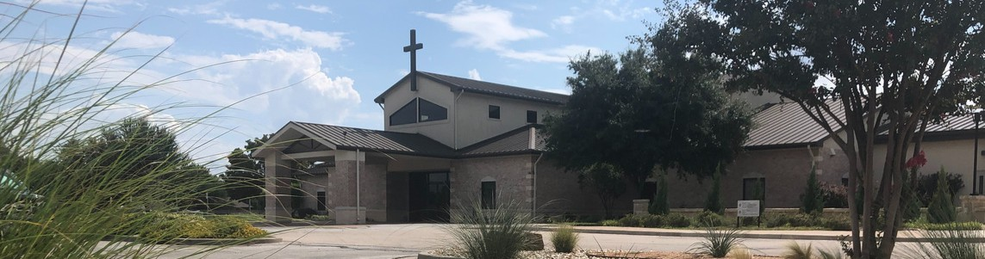



April 26, 2026

Welcome to Fellowship!

Thank you for joining us for worship today! If you are a first-time visitor, please visit our Welcome Desk in the foyer or scan the QR code at right to complete a Guest Connect form.

Follow Us On Social Media

@fellowshipwaco

U P C O M I N G E V E N T S




For complete event details and registration, visit our website: fellowshipwaco.org/events
Need Assistance?
Visit the South Foyer Welcome Desk and our friendly Welcome Team will be glad to answer any questions or help you find the information you’re looking for!

Need Coffee?
Visit our Café in the North Foyer. Our Hospitality Team is ready to serve you!

Need Prayer?
If you would like someone to pray with you, our Prayer Team is available at the back of the Worship Center after each service.

Visit our website:
fellowshipwaco.org
Email us: office@fellowshipwaco.org
Read and subscribe to our weekly newsletter: fellowshipwaco.org
Download our church app: fellowshipwaco.org/app
Telephone: 254.848.7200
Sun. | Apr. 26 | Baptism Sunday
Sun. | Apr. 26 | Parenting Class
Sun. | Apr. 26 | Spanish Bible Study
Sun. | Apr. 26 | Foundations Class
Sun. | Apr. 26 | 18/24 Group
Tues. | Apr. 28 | Adult Bible Studies
Wed. | Apr. 29 | Fellowship Kids Ministry
Wed. | Apr. 29 | Student-Reach
Wed. | Apr. 29 | Adult Bible Studies
Wed. | Apr. 29 | GriefShare
Thur. | Apr. 30 | MomLIFE
Sun. | May 3 | ForeRunners Connection
Sun. | May 3 | Student Ministry Bake Sale

or scan the QR code at right.

Good Morning Fellowship!
How does your faith in Christ shape the way you work, especially when it’s hard, unfair, or frustrating? This morning, we’ll explore 1 Peter 2:18–20 and discover how our relationship with God empowers us with the grace and guidance to live out our faith at work.
Grant Kaul, Senior Pastor

O u r F a i t h a t W o r k

1 P e t e r 2 : 1 8 - 2 0

How do God’s people live out their faith at work, especially when the situation is hard, unfair, or unjust?
- Fulfill your role with all respect 2:18

4 Ways  to Give In Service
Boxes in Worship Center


Online
fellowshipwaco.org/giving

App
fellowshipwaco.org/app

Mail
P.O. Box 21655
Waco, TX 76702

Find your strength in God 2:19

- Focus your heart to do what is right 2:20

Whatever you do, do your work heartily, as for the Lord rather than for men, knowing that from the Lord you will receive the reward of the inheritance.
It is the Lord Christ whom you serve.
Colossians 3:23-24

Our relationship with God empowers us with
the grace and guidance to live out our faith at work.


Take Next
Steps Membership
fellowshipwaco.org/membership


Serve
fellowshipwaco.org/serve


Small Groups
fellowshipwaco.org/groups


My personal application of this passage:
Video from previous messages: youtube.com/fellowshipwaco Audio from previous messages: fellowshipwaco.org/podcasts Sermon notes online: fellowshipwaco.org/sermon-notes

Questions for individual study, small group Bible studies, and LIFE Groups:

  - In what specific ways does your current attitude or effort at work reflect or fail to reflect your relationship with Christ?

  - When you feel wronged or overlooked at work, what is your first instinct, and how can you intentionally shift your response to honor God?

  - What situations at work most test your patience or humility, and how can you prepare ahead of time to respond in a Christlike way?

  - Where might pride or a desire to prove yourself be shaping your reactions, and what would it look like to choose humility and trust in God instead?

  - How can your daily work become a platform to display the grace of God and point others to Christ through your actions and responses?

