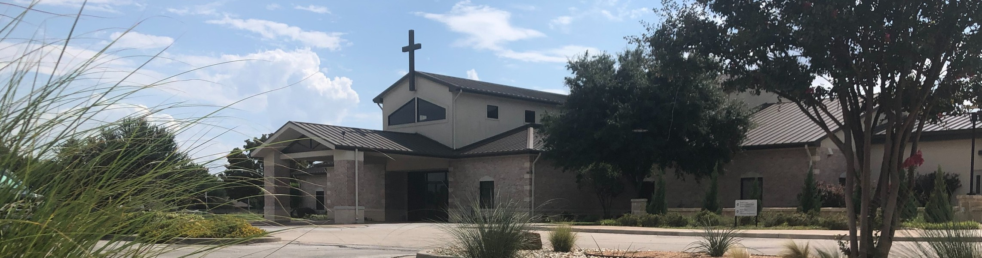



Easter Sunday April 5, 2026

Welcome to Fellowship!

Thank you for joining us for worship today! If you are a first-time visitor, please visit our Welcome Desk in the foyer or scan the QR code at right to complete a Guest Connect form.

Follow Us On Social Media

@fellowshipwaco

U P C O M I N G E V E N T S

Mon. Tues. Wed. Wed. Wed. Wed. Thur. Thur. Sun. Sun. Sun. Sun. Sat. Sun. Sun.
Apr. 6
Apr. 7
Apr. 8
Apr. 8
Apr. 8
Apr. 8
Apr. 9
Apr. 9
Apr. 12
Apr. 12
Apr. 12
Apr. 12
Apr. 18
Apr. 19
Apr. 26
Church Office Closed Adult Bible Studies Fellowship Kids Ministry Student-Reach



Adult Bible Studies GriefShare MomLIFE
Need Assistance?
Visit the South Foyer Welcome Desk and our friendly Welcome Team will be glad to answer any questions or help you find the information you’re looking for!

Need Coffee?
Visit our Café in the North Foyer. Our Hospitality Team is ready to serve you!

Need Prayer?
If you would like someone to pray with you, our Prayer Team is available at the back of the Worship Center after each service.

Visit our website:
fellowshipwaco.org
Email us: office@fellowshipwaco.org
Read and subscribe to our weekly newsletter: fellowshipwaco.org
Download our church app: fellowshipwaco.org/app
Telephone: 254.848.7200
ForeRunners Outing & Lunch Spanish Bible Study Foundations Class
Equipped for LIFE 18/24 Group LiveWires Event
Discover LIFE Membership Class Baptism Sunday

For complete event details and registration, visit our website: fellowshipwaco.org/events
or scan the QR code at right.

Good Morning Fellowship!
Moments before His death, Jesus cried out, “Tetelestai—It is finished.” But what did He finish, and what does that mean for you? This Resurrection Sunday, we will discover and celebrate the life-changing truth that can transform our lives forever.
Grant Kaul, Senior Pastor

T h e L i f e - C h a n g i n g T r u t h A b o u t “ T e t e l e s t a i - I t i s F i n i s h e d ”

J o h n 2 0 : 1 - 1 0

Therefore when Jesus had received the sour wine, He said, “It is finished!” (tetelestai) And He bowed His head and gave up His spirit.
John 19:30

Will you believe in Jesus and His declaration of “Tetelestai – It is finished”?

- The unexpected event 20:1–2

4 Ways
to Give In Service
Boxes in Worship Center


Online
fellowshipwaco.org/giving

App
fellowshipwaco.org/app

Mail
P.O. Box 21655
Waco, TX 76702

- The undeniable evidence 20:3–8

- The unmistakable emphasis 20:8–10

What will you do with the evidence?

“I am the way, and the truth, and the life;
no one comes to the Father but through Me.”
John 14:6

“...but these have been written so that you may believe that Jesus is the Christ, the Son of God; and that believing you may have life in His name.”
John 20:31
How well do you see this Easter? What is your salvation status?

Our response to Christ’s resurrection reveals
if we have received His “paid in full” salvation.

Tetelestai – It is finished!


Take Next
Steps Membership
fellowshipwaco.org/membership


Serve
fellowshipwaco.org/serve


Small Groups
fellowshipwaco.org/groups


My personal application of this passage:
Video from previous messages: youtube.com/fellowshipwaco Audio from previous messages: fellowshipwaco.org/podcasts Sermon notes online: fellowshipwaco.org/sermon-notes

Questions for individual study, small group Bible studies, and LIFE Groups:

- Where do you see yourself in the progression from awareness, to investigation, to belief when it comes to Jesus’ finished work? Can you share a key step in your journey?

- What are some ways people today try to “add to” what Jesus has already finished, and how can you guard your heart against that?

- How does understanding that your sin has been “paid in full” change the way you deal with guilt, shame, or fear in your daily life?

- What evidence for the resurrection most strengthens your faith, and how can you use that to encourage or share with others?

- In what specific area of your life do you need to more fully live in the freedom and confidence of Tetelestai this week?

