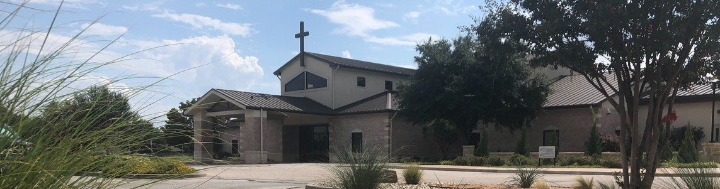



June 14, 2026

Welcome to Fellowship!

Thank you for joining us for worship today! If you are a first-time visitor, please visit our Welcome Desk in the foyer or scan the QR code at right to complete a Guest Connect form.

Follow Us On Social Media

@fellowshipwaco

U P C O M I N G E V E N T S

Sun. Wed. Thur. Thur. Fri.
Sat. Sat. Sun. Sun. Sun. Wed. Sun. Sun.
June 14
June 17
June 18
June 18
June 19
June 20
June 20
June 21
June 21
June 21
June 24
June 28
June 28
Spanish Bible Study



Adult Summer Bible Studies MomLIFE Playdate-Arboretum LiveWires Pool Party
Need Assistance?
Visit the South Foyer Welcome Desk and our friendly Welcome Team will be glad to answer any questions or help you find the information you’re looking for!

Need Coffee?
Visit our Café in the North Foyer. Our Hospitality Team is ready to serve you!

Need Prayer?
If you would like someone to pray with you, our Prayer Team is available at the back of the Worship Center after each service.

Visit our website:
fellowshipwaco.org
Email us: office@fellowshipwaco.org
Read and subscribe to our weekly newsletter: fellowshipwaco.org
Download our church app: fellowshipwaco.org/app
Telephone: 254.848.7200
Student Ministry Event Men’s Serve Day
MomLIFE Moms’ Only Breakfast Child Dedication
Spanish Bible Study Equipped for LIFE - Prayer Adult Summer Bible Studies Spanish Bible Study
E3 Event

For complete event details and registration, visit our website: fellowshipwaco.org/events
or scan the QR code at right.

Good Morning Fellowship!
When life feels uncertain, where do you turn? When suffering comes, what sustains you? Where does real hope come from? Peter points us to our living hope: Jesus Christ, who is risen and reigning. Because He lives, we have a living hope that sustains us in every season of life.
Curtis Fahrlender, Associate Pastor

R i s e n a n d R e i g n i n g :
T h e L i v i n g H o p e T h a t S u s t a i n s U s

1 P e t e r 3 : 1 8 - 2 2

The resurrection of Christ secures our hope 3:18

4 Ways  to Give In Service
Boxes in Worship Center


Online
fellowshipwaco.org/giving

App
fellowshipwaco.org/app

Mail
P.O. Box 21655
Waco, TX 76702

The revelation of Christ is the source of our hope 3:19-21

- The reign of Christ sustains our hope 3:22


Take Next
Steps Membership
fellowshipwaco.org/membership


Serve
fellowshipwaco.org/serve


Small Groups
fellowshipwaco.org/groups


My personal application of this passage:
Video from previous messages: youtube.com/fellowshipwaco Audio from previous messages: fellowshipwaco.org/podcasts Sermon notes online: fellowshipwaco.org/sermon-notes

Questions for individual study, small group Bible studies, and LIFE Groups:

- Peter tells us that Jesus suffered “to bring you to God.” When you think about being brought near to God through Christ, what thoughts come to mind?

- In what ways does 1 Peter 3:18 affect the way you view God’s love, and how might it impact the way you respond to others?

- How does Christ’s example of suffering encourage you during difficult seasons with hope and faithfulness?

- How does knowing that Christ’s resurrection defeats every power of darkness give you confidence every day?

