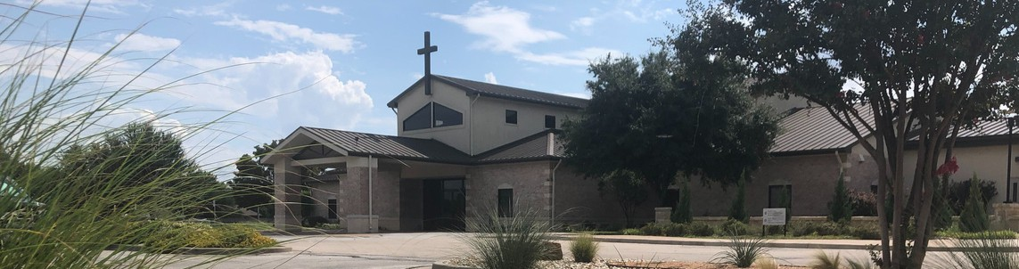



June 21, 2026

Welcome to Fellowship!

Thank you for joining us for worship today! If you are a first-time visitor, please visit our Welcome Desk in the foyer or scan the QR code at right to complete a Guest Connect form.

Follow Us On Social Media

@fellowshipwaco

U P C O M I N G E V E N T S

Sun. Sun. Sun. Wed. Sun. Sun. Sun. Sun. Wed. Sun. Sun. Sun.
June 21
June 21
June 21
June 24
June 28
June 28
June 28
June 28
July 1
July 5
July 5
July 5
Child Dedication Spanish Bible Study



Equipped for LIFE - Prayer Adult Summer Bible Studies Spanish Bible Study Watermelon Sale - GBBMI 18/24 Young Adults
Need Assistance?
Visit the South Foyer Welcome Desk and our friendly Welcome Team will be glad to answer any questions or help you find the information you’re looking for!

Need Coffee?
Visit our Café in the North Foyer. Our Hospitality Team is ready to serve you!

Need Prayer?
If you would like someone to pray with you, our Prayer Team is available at the back of the Worship Center after each service.

Visit our website:
fellowshipwaco.org
Email us: office@fellowshipwaco.org
Read and subscribe to our weekly newsletter: fellowshipwaco.org
Download our church app: fellowshipwaco.org/app
Telephone: 254.848.7200
E3 Event - What is AI
Adult Summer Bible Studies Spanish Bible Study ForeRunners Connection 18/24 Young Adults



For complete event details and registration, visit our website: fellowshipwaco.org/events
or scan the QR code at right.

Good Morning Fellowship!
One of my favorite parts of playing sports was the pregame pep talk. The passion, the excitement, the expectation, the challenge. Those talks were given to provide the reality of what we were about to walk into and ready us for the competition we were to face. Every day as believers we face an enemy that seeks to kill, steal, and destroy. We need more than a pep talk. We need the armor of God! This morning we begin a summer study from Ephesians 6:10-20 entitled, “Standing Strong: Living in the Power of the Armor of God”.
I can’t wait to worship with you!

George Ohmstede, Associate Pastor

P r e p a r i n g f o r t h e B a t t l e :
U n d e r s t a n d i n g W h o t h e E n e m y I s a n d W h a t W e M u s t D o t o B e F u l l y P r e p a r e d t o F a c e H i m

E p h e s i a n s 6 : 1 0 - 1 3

- Be Strong v. 10

- Put On v. 11

4 Ways
to Give In Service
Boxes in Worship Center


Online
fellowshipwaco.org/giving

App
fellowshipwaco.org/app

Mail
P.O. Box 21655
Waco, TX 76702

- Understanding Our Struggle and Our Enemy v. 12

- Take Up v. 13

- Stand Firm v. 13

We stand firm in the faith by growing strong in the Lord and His truth.


Take Next
Steps Membership
fellowshipwaco.org/membership


Serve
fellowshipwaco.org/serve


Small Groups
fellowshipwaco.org/groups


My personal application of this passage:
Video from previous messages: youtube.com/fellowshipwaco Audio from previous messages: fellowshipwaco.org/podcasts Sermon notes online: fellowshipwaco.org/sermon-notes

Questions for individual study, small group Bible studies, and LIFE Groups:

  - In verse 10 Paul says, “Be strong in the Lord and in the strength of His might.” What does it look like practically for us to grow strong in the Lord and His truth rather than relying on our own strength? Share one area of your life where you currently feel weak and how you might draw strength from the Lord in that situation.

  - Why is it important that we put on the FULL armor and not just pieces of it? What are some practical ways you can daily “put on” this armor before the day begins?

  - Verse 12 reminds us that “our struggle is not against flesh and blood” but against spiritual forces of evil. How does remembering who the real enemy is change the way we respond to conflict with people (family, coworkers, church members, etc.)? Give an example of a time you mistakenly fought “flesh and blood” instead of recognizing the spiritual battle.

  - After describing the enemy, Paul says to “take up the full armor of God, so that when the day of evil comes, you may be able to stand firm.” What does “standing firm” look like in everyday life? How can we prepare now so that we’re not caught off guard when the “day of evil” arrives?

  - Looking at the whole passage and the sermon title “Preparing for the Battle,” what is one specific step you sense God is asking you to take this week to be better prepared for spiritual battle?

