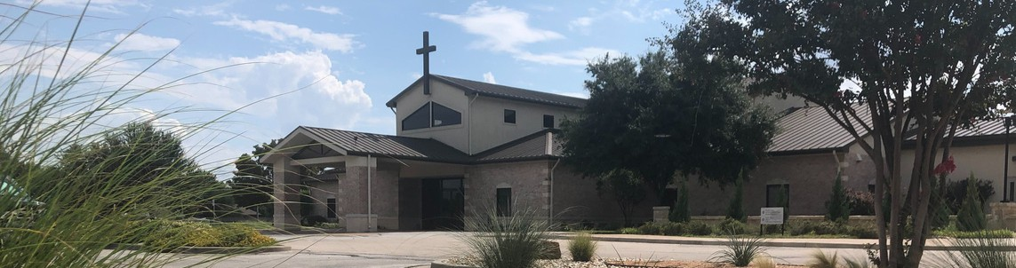



July 26, 2026

Welcome to Fellowship!




Thank you for joining us for worship today! If you are a first-time visitor, please visit our Welcome Desk in the foyer or scan the QR code at right to complete a Guest Connect form.
Need Assistance?
Visit the South Foyer Welcome Desk and our friendly Welcome Team will be glad to answer any questions or help you find the information you’re looking for!

Need Coffee?
Visit our Café in the North Foyer. Our Hospitality Team is ready to serve you!

Need Prayer?
If you would like someone to pray with you, our Prayer Team is available at the back of the Worship Center after each service.

Visit our website:
fellowshipwaco.org
Email us: office@fellowshipwaco.org
Read and subscribe to our weekly newsletter: fellowshipwaco.org
Download our church app: fellowshipwaco.org/app
Telephone: 254.848.7200

Follow Us On Social Media

@fellowshipwaco

U P C O M I N G E V E N T S

Sun. Sun. Sun.
July 26
July 26
July 26
Spanish Bible Study PLACE Workshop 18/24 Young Adults

Wed. July 29 Adult Bible Studies

Sun. Sun. Sun. Sun. Sun. Sun.
Aug. 2
Aug. 2
Aug. 2
Aug. 2
Aug. 2
Aug. 9
Spanish Bible Study
Women’s Ministry Open House PLACE Workshop
18/24 Young Adults ForeRunners Connection Promotion Sunday

Student Ministry Mission Camp
July 26-August 1
Daily prayer guides are available at the Welcome Desk.
Early Childhood & Kids Ministry
During the month of July, Kids Ministry and Early Childhood Classes will meet during
2nd service only.
For complete event details and registration, visit our website: fellowshipwaco.org/events
or scan the QR code at right.

Good Morning Fellowship!
Where does your mind find strength? This morning, we are exploring the next piece of the Armor of God—the Helmet of Salvation. Salvation is not just a past event or a future promise; it is a present reality that strengthens our minds and fills us with hope. Let’s worship together as we continue our “Standing Strong” series with the Helmet of Salvation—the piece of armor that protects our minds and secures our hope.
Curtis Fahrlender, Associate Pastor

S t r e n g t h o f M i n d :
T h e H e l m e t o f S a l v a t i o n

E p h e s i a n s 6 : 1 7

- Take: Receive What God Has Given

4 Ways
to Give In Service
Boxes in Worship Center


Online
fellowshipwaco.org/giving

App
fellowshipwaco.org/app

Mail
P.O. Box 21655
Waco, TX 76702

- The Helmet: Renewing the Mind

  - Recall God’s Mercies (Romans 12:1)

  - Resist the World’s Mold (Romans 12:2a)

  - Respond to the Word of God (Romans 12b)

- Salvation: Resting in Hope (1 Thessalonians 5:8)


Take Next
Steps Membership
fellowshipwaco.org/membership


Serve
fellowshipwaco.org/serve


Small Groups
fellowshipwaco.org/groups


My personal application of this passage:
Video from previous messages: youtube.com/fellowshipwaco Audio from previous messages: fellowshipwaco.org/podcasts Sermon notes online: fellowshipwaco.org/sermon-notes

Questions for individual study, small group Bible studies, and LIFE Groups:

- What are some situations in which you have worn a helmet?

- Why is the mind such a critical battleground?

- How does the helmet of salvation help you stand firm?

- What practical steps can you take to guard your thoughts?

