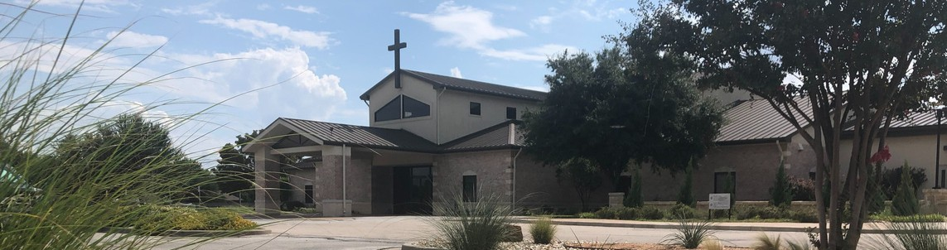



July 5, 2026

Welcome to Fellowship!

Thank you for joining us for worship today! If you are a first-time visitor, please visit our Welcome Desk in the foyer or scan the QR code at right to complete a Guest Connect form.

Follow Us On Social Media

@fellowshipwaco

U P C O M I N G E V E N T S

Sun. Sun. Wed. Thur. Sun. Wed. Thur. Sat. Sun. Sun. Sun. Sun. Sun.
July 5
July 5
July 8
July 9
July 12
July 15
July 16
July 18
July 19
July 19
July 19
July 19
July 19
ForeRunners Connection 18/24 Young Adults



Adult Summer Bible Studies ForeRunners Lunch
Need Assistance?
Visit the South Foyer Welcome Desk and our friendly Welcome Team will be glad to answer any questions or help you find the information you’re looking for!

Need Coffee?
Visit our Café in the North Foyer. Our Hospitality Team is ready to serve you!

Need Prayer?
If you would like someone to pray with you, our Prayer Team is available at the back of the Worship Center after each service.

Visit our website:
fellowshipwaco.org
Email us: office@fellowshipwaco.org
Read and subscribe to our weekly newsletter: fellowshipwaco.org
Download our church app: fellowshipwaco.org/app
Telephone: 254.848.7200
18/24 Young Adults
Adult Summer Bible Studies LiveWires Pool Party
Men’s Breakfast Spanish Bible Study
It’s Good to be a LiveWire Day PLACE class begins
Discover Missions MomLIFE Lemonade Stand

Early Childhood & Kids Ministry
During the month of July, Kids Ministry and Early Childhood Classes will meet during
2nd service only.
For complete event details and registration, visit our website: fellowshipwaco.org/events
or scan the QR code at right.

Good Morning Fellowship!
Every one of us faces impact - temptation, accusation, pressures, and pain. Today, we continue our series, “Standing Strong: Living in the Power of the Armor of God”. As we explore the breastplate of righteousness, we will be reminded that it is Christ’s righteousness that is our defense, our identity, and our strength to stand firm when life strikes.
Curtis Fahrlender, Associate Pastor

P r e p a r i n g f o r I m p a c t :
T h e B r e a s t p l a t e o f R i g h t e o u s n e s s

E p h e s i a n s 6 : 1 4

- Positional Righteousness: Righteousness as Our Identity 1 Corinthians 1:26-31

4 Ways
to Give In Service
Boxes in Worship Center


Online
fellowshipwaco.org/giving

App
fellowshipwaco.org/app

Mail
P.O. Box 21655
Waco, TX 76702

- Practical Righteousness: Living in Righteousness Titus 2:11-15

- Protective Righteousness: Guarding Your Heart Proverbs 4:23-27


Take Next
Steps Membership
fellowshipwaco.org/membership


Serve
fellowshipwaco.org/serve


Small Groups
fellowshipwaco.org/groups


My personal application of this passage:
Video from previous messages: youtube.com/fellowshipwaco Audio from previous messages: fellowshipwaco.org/podcasts Sermon notes online: fellowshipwaco.org/sermon-notes

Questions for individual study, small group Bible studies, and LIFE Groups:

  - How does righteousness function as a breastplate?

  - What might Paul be trying to communicate by likening it to armor that protects our heart?

  - Why is protecting our hearts (emotions, desires) with righteousness so important in the context of spiritual warfare?

  - How can we cultivate a deeper sense of righteousness in our lives?

  - What practices can help us “put on” righteousness each day?

