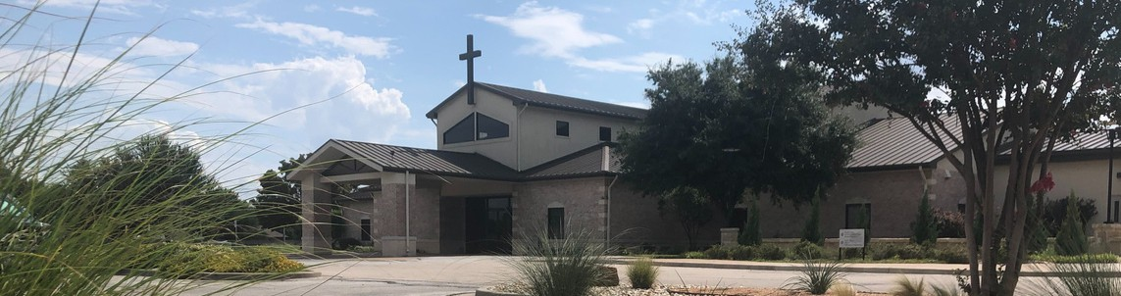



August 30, 2026

Welcome to Fellowship!

Thank you for joining us for worship today! If you are a first-time visitor, please visit our Welcome Desk in the foyer or scan the QR code at right to complete a Guest Connect form.

Follow Us On Social Media

@fellowshipwaco

T O D A Y

Sun. Sun. Sun. Sun. Sun.
Aug. 30
Aug. 30
Aug. 30
Aug. 30
Aug. 30
9:00am 9:00am 10:45am
10:45am
12:30pm
Prayer Group (Cedar Room - South Foyer) Spanish Bible Study (Acacia Room - South Foyer) PLACE Workshop (Cypress Room - North Foyer)
Stephen Ministry Interest Meeting (Sycamore Room) 18/24 Young Adults (The Loft - North Foyer)

U P C O M I N G E V E N T S

Wed. Wed. Sun. Tues. Wed. Thur. Thur. Sun.
Sept. 2
Sept. 3
Sept. 6
Sept. 8
Sept. 9
Sept. 10
Sept. 10
Sept. 12
6:30pm 9:00am 10:45am
10:00am
6:30pm 8:45am 10:00am
8:30am
SM Reach (Worship Center)
MomLIFE Kick Off (Slow Rise, Woodway) ForeRunners Connection (Sycamore Room) Adult Bible Studies Begin
Wednesday Night Ministries Begin MomLIFE Begins (North Foyer) ForeRunners Trip to Marlin
Women’s Fellowship Breakfast (Fellowship Cafe)

For complete event details and registration, visit our website: fellowshipwaco.org/events or scan the QR code at right.

Need Assistance? Need Coffee? Need Prayer?

Visit the South Foyer Welcome Desk. Our team will be glad to help!
Visit our Café in the North Foyer. Our team is ready to serve you!
Prayer Team is available at the back of the Worship Center after each service.

Good Morning Fellowship!
How then shall we live in light of the end of all things and Christ’s return? In 1 Peter 4:7–9, Peter offers a timely and deeply practical answer that challenges us to consider how our future hope is shaping our lives today.
Grant Kaul, Senior Pastor

P r e s e n t P u r s u i t s o f
F u t u r e - F o c u s e d B e l i e v e r s

1 P e t e r 4 : 7 - 9

How then shall we live in light of the end of all things and Christ’s return?

Because the end is near, believers should pursue three present priorities.

- Think Clearly 4:7a

4 Ways
to Give In Service
Boxes in Worship Center


Online
fellowshipwaco.org/giving

App
fellowshipwaco.org/app

Mail
P.O. Box 21655
Waco, TX 76702

- Pray Watchfully 4:7b

- Love Fervently 4:8-9

Let our future hope produce present faithfulness.


Take Next
Steps Membership
fellowshipwaco.org/membership


Serve
fellowshipwaco.org/serve


Small Groups
fellowshipwaco.org/groups



My personal application of this passage:

Escanee el código QR para la traducción al español.

Video from previous messages: youtube.com/fellowshipwaco Audio from previous messages: fellowshipwaco.org/podcasts Sermon notes online: fellowshipwaco.org/sermon-notes

Questions for individual study and LIFE Groups:

  - What fears, distractions, or influences most often cloud your judgment, and how can Scripture help steady your perspective?

  - When pressure or temptation comes, what is usually your first response, and how can you develop a more watchful prayer life?

  - Where might God be calling you to remain faithful instead of becoming anxious, passive, or preoccupied with the future?

  - In which relationship is Christ calling you to stretch beyond comfort through patience, forgiveness, or sacrificial love?

  - Who could you intentionally welcome, encourage, or serve this week as an expression of Christlike hospitality?

