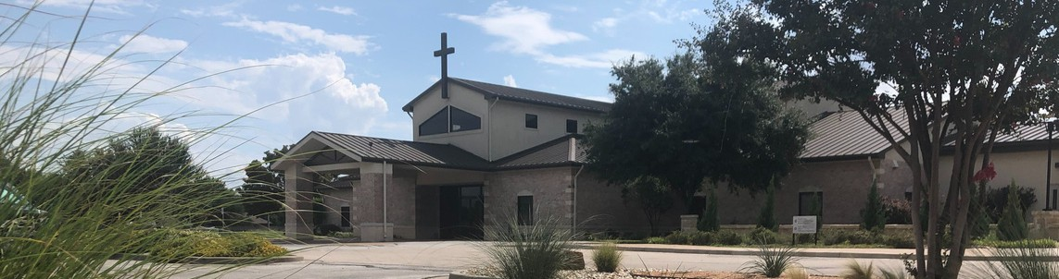



August 9, 2026

Welcome to Fellowship!

Thank you for joining us for worship today! If you are a first-time visitor, please visit our Welcome Desk in the foyer or scan the QR code at right to complete a Guest Connect form.

Follow Us On Social Media

@fellowshipwaco

U P C O M I N G E V E N T S

Sun. Sun. Sun. Sun. Sun. Thur. Thur. Sat. Sun. Sun. Sun. Sun. Sun. Sun.
Aug. 9
Aug. 9
Aug. 9
Aug. 9
Aug. 9
Aug. 13
Aug. 13
Aug. 15
Aug. 16
Aug. 16
Aug. 16
Aug. 16
Aug. 16
Aug. 16
Promotion Sunday Prayer Group Spanish Bible Study PLACE Workshop 18/24 Young Adults



ForeRunners Ice Cream Social MomLIFE Play Date-McGregor Men’s Breakfast
Need Assistance?
Visit the South Foyer Welcome Desk and our friendly Welcome Team will be glad to answer any questions or help you find the information you’re looking for!

Need Coffee?
Visit our Café in the North Foyer. Our Hospitality Team is ready to serve you!

Need Prayer?
If you would like someone to pray with you, our Prayer Team is available at the back of the Worship Center after each service.

Visit our website:
fellowshipwaco.org
Email us: office@fellowshipwaco.org
Read and subscribe to our weekly newsletter: fellowshipwaco.org
Download our church app: fellowshipwaco.org/app
Telephone: 254.848.7200
Prayer Group Spanish Bible Study PLACE Class
Discover LIFE Membership Class 18/24 Young Adults
SM Parent Meeting

Wed. Aug. 19
Wed. Aug. 19
LIFE Group Leaders Meeting Student Ministry Kick Off

Sun.
Aug. 23
E3 Night and Baptism

For complete event details and registration, visit our website: fellowshipwaco.org/events
or scan the QR code at right.

L e a r n i n g H o w t o P r a y a s a W a y o f L i f e
Good Morning Fellowship!
We often turn to prayer in a crisis, but what would change if prayer became the way we lived every day? In the capstone passage of our Standing Strong: Living in the Power of the Armor of God series, we will discover how a life of prayer enables us to rely on God’s strength, stand firm in the spiritual battle, and enjoy deeper fellowship with Him.

Grant Kaul, Senior Pastor

E p h e s i a n s 6 : 1 8 - 2 0

What does God teach us about cultivating a lifestyle of prayer?

- Pray with a dependence upon the Spirit 6:18a

4 Ways
to Give In Service
Boxes in Worship Center


Online
fellowshipwaco.org/giving

App
fellowshipwaco.org/app

Mail
P.O. Box 21655
Waco, TX 76702

- Pray with a determination to stay alert 6:18b

- Pray purposefully for people and God’s work 6:18b–20

Helpful prayer practices:

- Pray Scripture - Disciple’s Prayer in Matt 6:9-13; Eph. 1, 3; Phil 1; Col.1
- ACTS (Adoration, Confession, Thanksgiving, Supplication)
- Pray when God brings people or situations to mind.
- Start somewhere, even if it’s only 2 minutes a day.
- Pray out loud if you get distracted, or write or type out prayers.
- Pray as you go through the day.

We stand strong in the armor of God when prayer becomes our way of life.


Take Next
Steps Membership
fellowshipwaco.org/membership


Serve
fellowshipwaco.org/serve


Small Groups
fellowshipwaco.org/groups


My personal application of this passage:
Video from previous messages: youtube.com/fellowshipwaco Audio from previous messages: fellowshipwaco.org/podcasts Sermon notes online: fellowshipwaco.org/sermon-notes

Questions for individual study, small group Bible studies, and LIFE Groups:

  - What keeps prayer from becoming a natural part of your everyday life? What could help you turn to God more consistently throughout the day?

  - Where are you currently relying on your own strength rather than depending on the Holy Spirit through prayer?

  - What distractions or discouragements make it difficult for you to remain spiritually alert and persistent in prayer? How can you respond to them?

  - Whom might God be calling you to “stand in the gap” for through faithful prayer? What spiritual need could you begin praying about for that person?

  - Paul prayed for courage and the right words to represent Christ faithfully. Where do you need greater clarity or boldness to speak about Christ, and how can the group pray for you?

