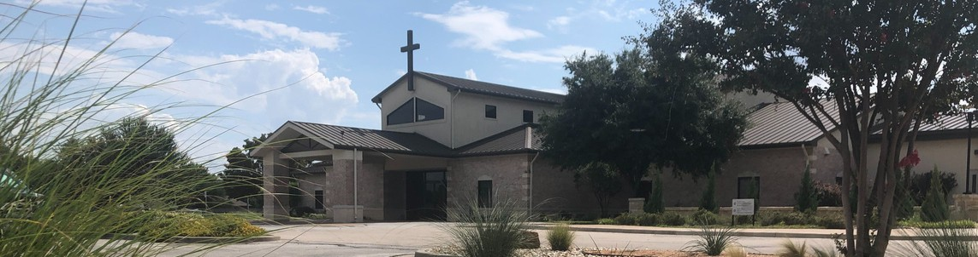



September 13, 2026

Welcome to Fellowship!

Thank you for joining us for worship today! If you are a first-time visitor, please visit our Welcome Desk in the foyer or scan the QR code at right to complete a Guest Connect form.

Follow Us On Social Media

@fellowshipwaco

Sun. Sun. Sun. Sun. Sun.
T O D A Y
Sept. 13
Sept. 13
Sept. 13
Sept. 13
Sept. 13
9:00am 9:00am 10:45am
12:15pm
12:30pm
Prayer Group (Cedar Room - South Foyer) Spanish Bible Study (Acacia Room - South Foyer) Foundations Class (Acacia Room -South Foyer) 18/24 Young Adults (The Loft - North Foyer)
SM Picnic & Park Day (Woodway Park)

U P C O M I N G E V E N T S

Tues. Wed. Wed.
Sept. 15
Sept. 16
Sept. 16
10:00am
6:30pm 6:30pm
Adult Bible Studies Wednesday Night Ministries SM Water Wars Party

Thurs. Sept. 17
8:45am
MomLIFE

Sat. Sat. Sun.
Sept. 19
Sept. 19
Sept. 20
8:00am 8:00am 10:45am
Men’s Breakfast SM Service Project
Equipped For LIFE Class

For complete event details and registration, visit our website: fellowshipwaco.org/events or scan the QR code at right.

Need Assistance? Need Coffee? Need Prayer?

Visit the South Foyer Welcome Desk. Our team will be glad to help!
Visit our Café in the North Foyer. Our team is ready to serve you!
Prayer Team is available at the back of the Worship Center after each service.

Good Morning Fellowship!
Trials do more than make life difficult. They reveal what our faith is made of. When faithfulness to Christ costs something, 1 Peter 4:12–16 shows us how to stand firm without becoming discouraged or ashamed and how our response can testify to Christ's sufficiency.
Grant Kaul, Senior Pastor

T r i e d a n d T r u e

1 P e t e r 4 : 1 2 - 1 6

How should believers respond when faithfulness to Christ brings suffering?
- Expect testing in this life 4:12

- Embrace your identity in Christ 4:13–14

So they went on their way from the presence of the Council, rejoicing that they had been considered worthy to suffer shame for His name.
Acts 5:41

4 Ways
to Give In Service
Boxes in Worship Center


Online
fellowshipwaco.org/giving

App
fellowshipwaco.org/app

Mail
P.O. Box 21655
Waco, TX 76702

- Examine your conduct 4:15

- Exalt God through your response 4:16

But about midnight Paul and Silas were praying and singing hymns of praise to God, and the prisoners were listening to them.
Acts 16:25

Suffering becomes a testimony when
our response makes Christ's sufficiency visible.


Take Next
Steps Membership
fellowshipwaco.org/membership


Serve
fellowshipwaco.org/serve


Small Groups
fellowshipwaco.org/groups



My personal application of this passage:

Escanee el código QR para la traducción al español.

Video from previous messages: youtube.com/fellowshipwaco Audio from previous messages: fellowshipwaco.org/podcasts Sermon notes online: fellowshipwaco.org/sermon-notes

Questions for individual study and LIFE Groups:

  - What has a recent trial revealed about where you are placing your trust, and how might God be using it to strengthen your faith?

  - When faithfulness to Christ brings criticism, rejection, or loss, what helps you remember your identity in Christ and respond with joy rather than shame?

  - How can you tell the difference between suffering for Christ and suffering because of your own poor choices, attitudes, or conduct?

  - When you are under pressure or facing suffering, what attitudes and words tend to flow from your life, and how might Christ use those moments to help you grow in grace, courage, prayer, and dependence upon Him?

  - What is one way you can glorify God in a current difficulty by making the sufficiency of Christ more visible through your response?

